Market Efficiency as a Trigger-Dependent State: Localisation and Forward Returns in a Screened International Panel
Abstract. Ahmed and Satchell (2018) model weak-form efficiency as a state selected by an exogenous trigger in a threshold autoregression, demonstrating it on two developed indices under two US-centric triggers. We ask what that measure can compare once it is taken to 23 equity indices under a single common trigger, the amplitude-adjusted Global OECD Consumer Confidence Indicator.
The estimator identifies a genuine three-regime split when the trigger belongs to the market: applying the same placebo to the original pairings, the fitted improvement clears a persistence-matched null at p = 0.006 and p < 0.001. Under the common trigger it does so in 3 of 23 indices. Market depth does not explain the difference, since the S&P 500 also fails under the common trigger despite endogeneity that would bias the test toward passing. Individual band shares are correspondingly imprecise, the median bootstrap interval being wider than the spread across the whole panel. What survives specification change is coarser: 22 of 23 indices retain the same dominant band across seven alternatives.
Trigger domain is the mechanism. On a matched Greek sample the global trigger leaves 83 percent of observations in the random-walk band, while the Greek indicator moves the sovereign-debt crisis into the low-sentiment band.
Twelve-month returns average 14.6, 8.0 and −7.5 percent after low, middle and high-sentiment months. The high-sentiment gap survives dependence correction, but a fixed decile rule reproduces it and 29 of 30 high-sentiment spells fall within the 1997 to 2000 euphoria.
The framework travels. A single common trigger does not.
1 Introduction
Fama (1965) characterised an efficient market as one whose prices follow a random walk. For decades the weak form of the hypothesis was evaluated as a binary property, with a market judged on average over a sample period to be either efficient or not. Lo (2004) subsequently proposed the adaptive market hypothesis, where efficiency varies over time with market conditions rather than holding as a fixed property. The measures developed in this tradition quantify efficiency as a statistical distance from randomness. They report how inefficient a market is, but not the kind of inefficiency it is experiencing.
Ahmed and Satchell (2018) address this directly. They model equity prices as a threshold autoregression where an exogenous trigger variable determines which of three regimes is active at each point in time, according to whether it lies below, between, or above two estimated thresholds. The regimes are a mean-reverting state associated with correction, a random-walk state that is efficient in the weak-form sense, and a locally explosive state associated with bubble-like dynamics. Efficiency thereby becomes one of several discrete states whose estimated dynamics can be examined rather than assumed. Because the same specification can be estimated for any market, the proportion of time spent in the middle state provides a common model output. That output is uniform in form across markets; it is not automatically uniform in meaning. Two further conditions decide whether it is. The fitted thresholds must be comparable in meaning, since the same numerical level need not correspond to the same domestic condition in every market. And the trigger must lie within each market's information domain, meaning it carries information about the conditions that market actually responds to. Section 4 examines the first condition, Section 5 the second.
Their application, however, is illustrative by design: two developed indices (the S&P 500 and FTSE 100) and two US-centric triggers (the Michigan Consumer Sentiment Index and the VIX). Their paper’s aim is to specify and estimate the metric, so it does not test whether the estimated states carry forward-looking information. The authors also acknowledge that finding an appropriate trigger is non-trivial and leave other assets and composite triggers to future research. Measures of deviation from randomness have meanwhile continued to appear (Noda, 2021; Shternshis, Mazzarisi and Marmi, 2022), but these retain the degree-based form rather than the state-based one. The gap between measuring the degree of inefficiency and identifying its economic character therefore remains largely open. This paper estimates the framework for 23 equity indices from 19 national jurisdictions under a single common trigger. What can the resulting classifications validly compare, once specification sensitivity, trigger domain and benchmark return content are treated as parts of the evidence?
First, the paper provides a systematic international implementation of Ahmed and Satchell's common-trigger TAR. The same switching-drift specification is estimated for 23 equity indices from 19 national jurisdictions that satisfy the maintained reverse-Granger screen, with the trigger and data treatment held fixed across the panel. For most indices, the estimated lower thresholds cluster between approximately 97.0 and 98.5 and the upper thresholds between 101.2 and 102.4, while the positional random-walk shares reveal substantial point-estimate heterogeneity.
That heterogeneity is easier to observe than to interpret. Five separate checks explain why it cannot be read as a ranking. First, the thresholds do not share domestic-percentile meaning across markets (Appendix D.5). Second, block-bootstrap re-estimation makes individual shares too imprecise for a precise league table. Third, the middle-band restriction mostly holds, including under a price-blind re-test that removes the original check's dependence on the fitted boundary, with one exception (Brazil; Appendix D.3). Fourth, rankings shift under alternative minimum-regime rules and drift specifications. Fifth, the block placebo distinguishes the fitted RSS improvement from a persistent random trigger in only 3 of 23 indices.
Dominant-band membership is more stable than the ordering: across six minimum-regime rules (five, ten and fifteen percent of the sample, and twenty, thirty and forty observations per band) and a constant-drift refit, 22 of the 23 panel indices retain the same dominant band under all seven alternative specifications (C53).The exception is Japan, whose high-sentiment dominance survives three of seven and reverts to random-walk dominance under the tighter minimum-regime rules, which is the behaviour expected of the degenerate threshold documented in Section 4.3. This test covers dominant-band membership only, not the finer boundaries between the second, third and fourth groups, which rest on episode timing rather than band shares.
The metric's general dependence on drift is inherited from Ahmed and Satchell; the new panel result is that this dependence, together with threshold and band-size uncertainty, prevents a specification-invariant international ordering. Within the maintained common-trigger design, the cross-index estimates are informative as a heuristic grouping of fitted classifications, not as a specification-invariant league table of market efficiency. That boundary is itself a cross-market finding: it identifies the level of comparison the Ahmed and Satchell metric can support once threshold uncertainty, trigger domain and drift sensitivity are made explicit.
Second, the paper makes trigger-domain assessment an empirical part of the framework. Greece supplies the central matched-window result. The global CCI assigns 83 percent of Greek observations to the random-walk band and leaves much of the sovereign-debt crisis there; the Greek CCI instead assigns 44 percent to the low-sentiment band and reclassifies the crisis years into that positional band. A percentile-normalised Greek trigger produces almost identical shares. Because percentile ranking largely preserves the trigger's ordering, this is a numerical-scale sensitivity check rather than independent evidence that rules out competing explanations.
The correlation between national and global CCI changes provides a candidate screen for sentiment decoupling, while the wider cases define its limits: Turkey is mainly a sample-window contrast, Japan and Spain exhibit mismatches missed by their full-sample correlations, and China's national CCI does not align its domestic equity manias with the high-sentiment band. The result documents a matched-window contrast consistent with domain mismatch and one positional reclassification, not a validated universal trigger-selection rule or proof of correction dynamics.
Third, the paper characterises subsequent returns across the estimated bands. Twelve-month returns average +14.6 percent after low-sentiment months, +8.0 percent after random-walk months and -7.5 percent after high-sentiment months (n = 1,109 / 6,676 / 615). The high-sentiment gap remains negative under the primary fixed-label dependence corrections and, separately, when the complete threshold search is re-estimated in a calendar-month full-pipeline bootstrap that does not preserve overlapping-return serial dependence. It also remains negative under a one-month publication lag.
In an expanding-window final-vintage horse race, both the TAR high band and a fixed upper-tail CCI band retain conditional content. Separately, a direct Wald test on the full-sample joint regression cannot distinguish their coefficients. The fixed-tail benchmark therefore answers an attribution question: because the simpler sort reproduces the aggregate spread and the Wald test cannot separate the coefficients, the evidence does not support attributing the historical association uniquely to TAR threshold estimation. It locates the framework's contribution in state classification and trigger-domain diagnosis rather than forecasting superiority under this common-trigger design; the same estimator identifies genuine regime structure when the trigger matches the market (Section 4.1). Three results converge on the same reading: the block placebo distinguishes the fitted improvement in 3 of 23 indices, a fixed decile sort reproduces the aggregate spread without any estimated threshold, and re-timing the labels at random destroys the association in all 5,000 draws. Taken together they locate the return information in the trigger's position rather than in the estimated boundary.
The result is identified almost entirely by the 1997 to 2000 euphoria: 29 of 30 spells occur in that event, and the five-calendar-year p-value of 0.034 describes cross-index consistency within it rather than inference across independent euphorias. The sparse post-2015 sample does not confirm the relationship. The low-sentiment mean exceeds the random-walk mean in 19 of 23 indices, but its magnitude is inference-dependent. The contribution is a benchmarked historical return association with an explicit temporal boundary, not a general forecasting or alpha claim.
Taken together, these three contributions answer an open empirical question left by Ahmed and Satchell: what their state-classification metric can and cannot carry across markets under one common trigger. We find no later empirical application examining how the metric behaves in a common-trigger international panel. The panel identifies the defensible scale of cross-market comparison; the matched Greek case supplies a positive positional demonstration consistent with trigger-domain mismatch; and the fixed-tail benchmark locates the return evidence in a historically bounded association rather than TAR forecasting superiority. The paper therefore does more than add markets: under one coherent design, it maps the framework's international empirical reach, documents one observable domain failure and bounds the economic content of the resulting labels.
The remainder of the paper is organised as follows. Section 2 reviews time-varying market efficiency, explosive-behaviour tests and the trigger problem. Section 3 sets out the TAR framework, trigger selection, data and return design. Section 4 reports the cross-market classifications. Section 5 examines trigger domain and localisation, centred on the matched Greece comparison. Section 6 presents the horizon-return evidence and benchmarks. Section 7 discusses interpretation, limitations and trigger constructions that were considered but not retained. Section 8 concludes.

2 Literature Review
This paper draws on two literatures. The first asks whether, and when, equity markets are efficient. The second develops tests for explosive behaviour and rational bubbles. Ahmed and Satchell (2018) connect them by using a threshold framework that treats mean reversion, efficiency and explosiveness as states of a single price process. This section reviews both literatures and closes with the gaps the paper addresses.

2.1 From binary efficiency to a time-varying state
The weak form of the efficient market hypothesis holds that prices already embody the information in past prices, so returns are unpredictable and prices follow a random walk (Fama, 1965, 1970; Samuelson, 1965). For decades the hypothesis was tested as a verdict on a whole sample: a market was efficient, or it was not. Early challenges fit the same mould: De Bondt and Thaler (1985) documented long-horizon return reversals and read them as evidence against efficiency, again for the sample as a whole.
Lo (2004) changed the framing. Under the adaptive markets hypothesis (AMH), efficiency varies over time and across markets as participants compete, learn and adapt to changing conditions, so efficiency and inefficiency can coexist without contradiction. Urquhart and McGroarty (2016) provided early empirical support: across the S&P 500, FTSE 100, Nikkei 225 and EURO STOXX 50 over 1990 to 2014, rolling-window variance ratio and BDS tests show periods of significant predictability alternating with periods of none, and each market adapts differently to market conditions.
The empirical support has since broadened. Munir, Abd Sukor and Shaharuddin (2022) find a strong contrarian effect across South Asian emerging markets whose profits strengthen in down markets, high-volatility phases and crises, which they read as partial support for the AMH alongside persistent weak-form inefficiency. Okorie and Lin (2021) find that the COVID-19 pandemic shifted efficiency in some markets and not others: in the long term, Indian equities became less efficient and Russian equities more efficient, while the US and Brazil showed no substantial change at any horizon. The common thread is that predictability comes and goes with conditions, and it does so differently across markets. A sample-wide verdict averages over exactly this variation, so measuring efficiency requires a metric that varies over time and across markets.

2.2 Measuring the degree and incidence of inefficiency
Once efficiency is allowed to vary, the question becomes how much a market deviates from a random walk at a given time. Noda (2016, 2021) answers it with a time-varying autoregressive coefficient: the further the coefficient sits from zero in a given period, the less efficient the market. dos Santos, Fávero, Brugni and Serra (2024) measure inefficiency by how far the Hurst exponent sits from 0.5, its random-walk value, over rolling 500-day and 1,250-day windows for daily indices in 50 countries from 1990 to 2022. Efficiency comes and goes across their sample and worsens around global crises. Using multilevel models, they link a country’s efficiency to its institutions, and find less inefficiency where legal rights and capital-market regulation are stronger.
Both measures report a distance. Noda’s coefficient can sit above or below zero, and the Hurst exponent above or below 0.5, with the two sides meaning different things: persistence on one side, reversion on the other. The indices, however, are built from the size of the deviation, so the direction is discarded. A market correcting after a crash and a market trending into a bubble can produce the same reading. The number says how far a market is from randomness, and nothing about which way.
Ahmed and Satchell (2018) ask a different question: which state is the market in? Building on the threshold autoregression results of Knight and Satchell (2011) and Knight, Satchell and Srivastava (2014), they model equity prices as switching among a mean-reverting state, a random-walk state and a locally explosive state, with the active state selected by an exogenous trigger variable. The random-walk restriction defines the efficient state, and the share of months a market spends there becomes the efficiency metric. Their outer-state names combine trigger position with a proposed dynamic interpretation, which must be checked against the estimated slopes in any new application. The same specification can be estimated for any market with a valid trigger, so it produces a common conditional metric. Whether that metric has comparable economic meaning still depends on the trigger's domain and on the interpretation of the estimated thresholds. Their application covers two developed indices under two US-based triggers.

2.3 Testing for explosive behaviour and rational bubbles
Bubble tests ask when prices stop behaving like a random walk and turn locally explosive, the third state in the framework above. Phillips, Wu and Yu (2011) ran right-tailed unit root regressions over expanding windows, with a unit root as the null and explosive growth as the alternative, and used the test to date the exuberance in the 1990s Nasdaq. Results in this family are sensitive to the null hypothesis and the model specification chosen (Phillips, Shi and Yu, 2014). The original design has a separate limit: every window starts at the beginning of the sample, so once an early bubble has collapsed, the collapsed episode remains in every later window and depresses the statistic for subsequent bubbles. Phillips, Shi and Yu (2015) generalised the procedure to address this. The GSADF (generalised sup-ADF) lets both the window size and the start point vary, so later episodes are examined in windows that never contain the first, and it can date the start and end of each episode consistently.
The GSADF is now the standard tool and gets applied across asset classes (e.g. Li et al., 2021; for a survey see Skrobotov, 2023). Harvey, Leybourne and Whitehouse (2020) improve the dating of bubbles when a sample contains several. Whitehouse, Harvey and Leybourne (2023) monitor in real time for the onset of a crash once a bubble is under way, modelling the bubble as an explosive regime and the crash as a stationary one.

2.4 Limits of bubble tests and the case for a regime approach
The bubble tests have known weaknesses, documented from inside the literature. Evans (1991) showed, for the unit-root bubble tests of his day, that power falls as the number of bubbles and collapses in a series increases: an episode that inflates and then bursts looks far less explosive on average than one that only inflates. Monschang and Wilfling (2021) ran a modern check. In their Monte Carlo experiments, sup-ADF tests over-reject under leverage effects and leave a large share of true bubbles undetected.
Ahmed and Satchell (2018) found a further weakness by simulation. They generate three-state price series in which a locally explosive regime is active 10 percent of the time, and vary whether the process has a stationary distribution. Holding the bubble parameter and its frequency fixed, GSADF power falls from 17.6 to 9.0 percent once a stationary distribution exists, and reaches 1 to 4 percent in other designs. The mechanism is simple. The test presumes a process with no mean-reverting state, so corrections drag the estimated coefficient back toward unity and the explosive signal washes out. The test works best when no correction ever occurs, a condition real markets rarely satisfy.
By estimating observations separately within trigger-defined states, the threshold framework avoids combining correction and high-sentiment episodes in a single autoregressive coefficient. This is useful when the trigger carries economically relevant information for the market being classified. Unlike a right-tailed unit-root test, the framework can also represent a separate low-trigger state. The estimated within-band slopes must still determine whether correction or local explosiveness is supported empirically; trigger position alone does not establish either dynamic. The cost is therefore the trigger requirement: the approach stands or falls on the relevance, timing and predeterminedness of the conditioning variable.

2.5 Sentiment and the trigger problem
Ahmed and Satchell (2018) impose one requirement on the trigger: exogeneity. They tested a range of candidate variables and discarded those that failed Granger causality tests against the indices. Their chosen triggers were the MCSI, a monthly survey of US households, and the VIX. Their reasoning is that persistently high sentiment marks exuberance and persistently low sentiment marks correction.
Sentiment can predict returns. Baker and Wurgler (2006) established the result for the United States cross-section, and Schmeling (2009) finds, across 18 industrialised countries from 1985 to 2005, that a country's own consumer confidence negatively forecasts its aggregate stock returns: high sentiment precedes low returns. Vuong and Suzuki (2022) reach the same conclusion for twelve Asian and European markets over 2004 to 2016, where market-level composite indices built partly from national consumer confidence predict returns in the contrarian direction at horizons of three to twenty-four months. This evidence motivates asking whether trigger-defined labels have subsequent return content. Return predictability is not, however, a prerequisite for a trigger to define contemporaneous states, and using it as a selection requirement would make the later horizon test partly circular. The relevant prior requirements are instead predeterminedness and economic relevance to the market being classified. Section 6 therefore keeps the return test separate and asks whether labels produced without using forward returns subsequently differ in economic content.
The prediction varies across countries. Schmeling (2009) finds the effect is stronger where market integrity is lower and culture leans toward herding. Vuong and Suzuki (2022) find its strength and horizon depend on financial development, institutional governance and culture, and the moderation itself shifts over time and differs between their two regions. dos Santos et al. (2024) tie efficiency to the institutional environment (Section 2.2). This creates a tension for a cross-market application of the framework. Comparing efficiency across markets calls for one common trigger, estimated the same way everywhere. The heterogeneity evidence warns that a single sentiment measure may fit some markets and carry little information for others. This literature offers no procedure for choosing a trigger, and no way of telling in advance which markets a common trigger will fail.

2.6 Research gap
The literature leaves three empirical questions. Existing applications cover two developed indices under two US-based triggers (Ahmed and Satchell, 2018), and the papers citing that study mainly extend its theory. We found no later empirical application of the time-in-state metric.
Second, the trigger problem is open. Ahmed and Satchell call finding an appropriate trigger non-trivial and leave it to future research. The sentiment evidence is locally heterogeneous (Schmeling, 2009; Vuong and Suzuki, 2022), so a common trigger cannot be assumed to fit every market. No procedure exists for choosing one, and whether a simple diagnostic such as trigger correlation can identify where a common trigger will fail is untested.
Third, the labels have not been checked against what returns do next. Ahmed and Satchell place forecasting beyond their scope, and no later study has tested whether the estimated states, as opposed to the underlying sentiment measure directly, carry information about subsequent returns.
The paper addresses these gaps through three linked analyses: a common-trigger implementation across 23 screened indices, matched-window trigger-domain tests centred on Greece, and a horizon-return analysis benchmarked against fixed CCI tails.

3 Methodology

3.1 The threshold autoregressive framework
The model is Ahmed and Satchell’s (2018); we restate it here so the paper is self-contained. Let $P_{t}$ denote the log price of an equity index. Prices follow a first-order threshold autoregression,
$$P_{t}=ψ_{t-1}+ϕ_{t-1}P_{t-1}+η_{t}, η_{t}∼N\left(0,σ_{η}^{2}\right) \left(1\right)$$
where the drift $ψ_{t-1}$ and the slope $ϕ_{t-1}$ switch according to the position of an exogenous trigger variable $Z_{t-1}$ relative to two thresholds $c_{1}<c_{2}$:
$$\left(ψ_{t-1},ϕ_{t-1}\right)=\left\{\begin{matrix}\left(α_{1},β_{1}\right) & \text{if }Z_{t-1}<c_{1} \\ \left(α_{2},β_{2}\right) & \text{if }c_{1}≤Z_{t-1}<c_{2} \\ \left(α_{3},β_{3}\right) & \text{if }Z_{t-1}≥c_{2}\end{matrix}\right. \left(2\right)$$
The middle state is restricted to a random walk. Estimation is carried out in return form,
$$Δp_{t}=ψ_{t-1}+\left(ϕ_{t-1}-1\right) p_{t-1}+η_{t} \left(3\right)$$
Ahmed and Satchell use the same symbol for the slope in levels and returns. We distinguish the two by defining the return-form slope as the level-form slope minus one; a random walk therefore has a return-form slope of zero and a level-form slope of one. The middle band is restricted to this random-walk specification, so its time share is a model-based positional measure of efficiency; Section 7.2 reports the unrestricted check. The outer bands are estimated freely. Following Ahmed and Satchell, a low-trigger band with a negative return-form slope is labelled mean-reverting (MR), and the high-trigger band is labelled explosive (EXP). These inherited names describe trigger positions unless the estimated dynamics support them.
In Ahmed and Satchell's switching-drift estimates, the high-sentiment band has a positive intercept but a negative return-form slope for both indices. Our estimates also produce negative high-band slopes in every index with a populated high-sentiment band (Section 4). We therefore interpret MR and EXP as low- and high-sentiment positional labels in this application. A positive demeaned intercept is the band's conditional mean return; it does not establish an explosive autoregressive root.
Ahmed and Satchell, building on Knight and Satchell (2011) and Knight, Satchell and Srivastava (2014), give the conditions under which a process of this form is well behaved. With state probabilities $π_{j}=P\left(c_{j-1}≤Z_{t-1}<c_{j}\right)$, where $c_{0}=-∞$ and $c_{3}=+∞$, the process (with constant drift $ψ_{t-1}=α$, the case in which Knight and Satchell (2011) derive the result) has a stationary distribution if
j​πjlnβj<0 4
The mean exists if j​πjβj<1, in which case
EPt=j​πjαj1-j​πjβj 5
and the variance exists if
Eϕt-12=j​πjβj2<1 6
Condition (4) permits a locally explosive state (some $\left|β_{j}\right|>1$) inside a globally stationary process, provided the explosive state is visited rarely enough. This is the property that undermines right-tailed bubble tests (Section 2.4) and the property the threshold framework is built to accommodate. Conditions (4) to (6) are derived under the assumption that $Z_{t-1}$ is i.i.d. Consumer confidence indices are highly autocorrelated, so our trigger is closer to Markovian; Ahmed and Satchell note that a Markovian trigger does not affect the estimators or the estimation strategy, although the closed-form moments no longer apply, and we inherit the same caveat.
Estimation follows their double grid search. An $n$-point grid $\{m_{1},…,m_{n}\}$ is placed over the observed range of the trigger. For each candidate pair $\left(c_{1},c_{2}\right)=\left(m_{i},m_{k}\right)$ with $i<k$, the sample splits into three sub-samples by the position of $Z_{t-1}$, equation (3) is estimated on each sub-sample by least squares with $b_{2}=0$ imposed, and the total residual sum of squares
$$RSS\left(c_{1},c_{2}\right)=\sum_{t=2}^{T}{(}Δp_{t}-ψ_{t-1}-\left(ϕ_{t-1}-1\right) p_{t-1})^{2} \left(7\right)$$
is recorded. The pair minimising (7) delivers the threshold estimates and the state-specific parameters, with asymptotic standard errors computed on the selected split. Grid points are spaced so that more than two observations fall between consecutive points, since no sub-sample regression is possible with fewer than two. Our implementation translates the authors’ original MATLAB code to Python and was validated against their published Tables 7 and 8: thresholds and regime proportions for the S&P 500 and FTSE 100 under the MCSI match to grid resolution, with one caveat (the FTSE 100 no-drift $c_{2}$ differs, 61.8 against a published 82.6, on an objective surface flat to within 0.14 percent of RSS; the economic conclusion is unchanged).
With the estimated thresholds in hand, each month is assigned to a band by the position of the trigger, and the middle-band share is reported as the model's positional random-walk measure. The zero slope in that band is imposed during estimation, so the raw share does not independently test weak-form efficiency. We therefore re-estimate the middle-band slope without the restriction and adjust the 23 tests using Benjamini-Hochberg.
Generated-classification uncertainty is evaluated separately by re-running the complete grid search in every bootstrap draw. A wild bootstrap conditions on the observed trigger path; moving-block bootstraps resample the dependent variable and trigger jointly and supply a more conservative bound. These designs answer different questions and are reported together rather than collapsed into a single precision claim. For the horizon tests, the fixed-label moving-block bootstrap and Driscoll-Kraay estimates are the primary dependence corrections for both tails; the calendar-month full-pipeline bootstrap is a complementary check on generated-classification uncertainty.
Table 4.1 presents raw time-in-band shares, while Ahmed and Satchell (2018) restrict the term "inefficient" to states whose slope is statistically significant, explicitly declining to classify a state as inefficient where "the first state is not statistically significant." We report the raw share as the primary output and flag which slopes are individually significant, following the same distinction.

3.2 Trigger selection
Ahmed and Satchell require an exogenous trigger and describe trigger choice as non-trivial. This paper operationalises that requirement with a reverse-Granger screening rule and adds three further design screens: frozen-threshold stability, coverage of both trigger tails in fixed historical windows, and availability on a common numerical scale. None of the screens selects a trigger by subsequent returns. The reverse-Granger rule is a maintained diagnostic rather than a causal identification test, and the historical screens assess interpretability rather than establish a uniquely correct trigger.
First, the reverse-Granger screen tests whether lagged equity returns predict changes in the trigger. Rejection indicates feedback that is inconsistent with the maintained predetermined-trigger interpretation. Non-rejection is recorded as a screening pass and does not establish structural exogeneity. For each index i we estimate
$$Z_{t}=a_{0}+\sum_{l=1}^{q}{a_{l}}Z_{t-l}+\sum_{l=1}^{q}{d_{l}} r_{i,t-l}+u_{t} \left(8\right)$$
where r is the index's monthly log return (Delta p for index i in the notation of Section 3.1), and test the four return lags by F-test; per-index statistics are in Appendix A. Re-running the screen at eight lags, motivated by the longer-horizon feedback in Section 7.1, leaves 22 of the 23 admissible indices without a rejection. Japan rejects at p = 0.042 and is also the structural mismatch in Section 4.3; its high-sentiment months are excluded from the pooled horizon test. An index is labelled as passing when the null is not rejected. Throughout the paper, 'pass' refers only to this maintained predictive screen.
Second, frozen-threshold classification stability. This is a pseudo-out-of-sample exercise: thresholds estimated through mid-2015 are applied to later months, but the sentiment series are final-vintage data. It asks whether a trigger's own state mapping remains stable when the cut-offs are frozen; it does not call a label correct because the equity index subsequently rises or falls.
Rolling ten-year threshold ranges differ sharply, with 46.0 MCSI units against 4.8 CCI units, but those raw ranges partly reflect trigger construction and scaling and are descriptive only. Under thresholds frozen in mid-2015, the MCSI places the S&P 500 in its low-sentiment band from August 2025 onward, whereas the CCI remains in its middle band through April 2026 and enters its low-sentiment band in May. This difference illustrates baseline drift; it is not a return-based trigger horse race. The S&P 500 fails the maintained screen and the MCSI is US-only, so neither the example nor subsequent S&P returns select the panel trigger.
Across the admissible panel, frozen CCI labels agree with full-sample labels in 88 percent of index-months. Chance-corrected self-agreement is higher for the MCSI on the S&P 500 (kappa 0.94) than for the CCI across the panel (0.74), so internal label stability is not the CCI's advantage. A genuine equal-terms comparison would require panel-wide alternatives, real-time vintages and release dates.
Third, coverage of both tails. Fixed dot-com and GFC windows provide a common historical check on whether a candidate trigger spans states that can be interpreted as high sentiment and stress. The check concerns the trigger's own tail coverage, not whether contemporaneous or subsequent equity returns validate every label. Because the windows are historical and their boundaries are contestable, this is supporting interpretive evidence rather than an outcome-independent correctness criterion. A one-tailed trigger cannot identify both outer states. The VIX fails here: it spikes on fear and compresses during euphoria, so a high-trigger state cannot represent euphoria. Moody's BAA credit spread fails in the same direction, showing a mean compression of 0.52 percentage points during euphoric episodes against an intra-window range of 3.62 percentage points during the GFC; the two statistics measure different aspects of spread and the euphoria compression is insufficient for the threshold geometry to separate a high-sentiment state.
Fourth, availability across the panel on a common numerical scale. This permits the same estimation rule to be applied to every index, but it does not by itself give a threshold the same percentile or economic meaning in each national sentiment distribution.
Table 3.1 summarises the six candidates evaluated. The Chicago Fed's Adjusted National Financial Conditions Index (ANFCI) is numerically stable but shows threshold compression after 2010: the easy-money era pushes its thresholds toward zero and the high-sentiment band fires across a wide range in European markets (mean 47.1 percent, median 56.7 percent, range 1.3 to 83.0 percent, n = 19; 9 of 19 fail the screen), so the degenerate-threshold concern applies to a subset of markets. The Shiller cyclically-adjusted price-earnings ratio (CAPE) fails the reverse-Granger screen for the S&P 500 because it is constructed from the market price, and its thresholds range 21.4 units across windows; we retain it only as a second-stage characterisation variable. The BIS credit-to-GDP gap, a seventh candidate considered alongside the six in the table, was set aside because its cycles are largely domestic. The MCSI is not retained because it is US-only, not because its frozen label disagrees with a later equity outcome. The amplitude-adjusted Global OECD CCI is retained as a workable common trigger after applying the four design screens to final-vintage data. The screens eliminate unsuitable candidates; they do not rank all candidates on equal panel data or prove that the retained CCI is uniquely optimal or structurally exogenous. Section 7.1 reports the composite-trigger investigation.
Table 3.1. Candidate triggers against the four requirements.
Trigger | Reverse-Granger screen | Both-tailed | Global | Decision
MCSI | Yes (US only) | Yes | No | Not retained: US-only; frozen S&P case is descriptive
VIX | Yes | No (fear only) | Yes | Rejected: structurally one-tailed
BAA spread | Yes | No (euphoria mild) | Yes | Rejected: euphoria mean compression 0.52pp vs GFC intra-window range 3.62pp
ANFCI | Partial (9 fail) | Partial | Yes | Rejected: high-sentiment band fires 47% mean (range 1–83%) for European markets; 9 of 19 fail screen
CAPE | No (S&P endogenous) | Yes | Partial | Rejected as primary; second-stage characterisation only
Global OECD CCI | 32 of 57 pass screen | Yes | Yes | Selected for screened panel: both tails and common numerical scale
Note to Table 3.1: the global CCI passes the reverse-Granger screen for 32 of 57 candidate indices; the failures are screened out of the estimation panel. The four design screens are the reverse-Granger screen, frozen-threshold classification stability, coverage of both trigger tails in fixed historical windows, and availability on a common numerical scale. The stability exercise is conditional on final-vintage data and does not constitute an independent real-time out-of-sample test. The US-only MCSI cannot be compared with the global CCI on equal panel coverage; its S&P example is descriptive and does not select either trigger by equity outcomes. The CAPE and BAA rows come from archived studies in the replication package. Raw threshold ranges (MCSI 46 units, CCI 4.8) are descriptive and are not used as a selection statistic.
Figure 3.1. Rolling ten-year threshold estimates for the S&P 500: the MCSI (upper panel) shifts as crises enter the window, while the amplitude-adjusted US CCI (lower panel) moves less. The raw-range contrast is descriptive and does not provide a real-time out-of-sample comparison.
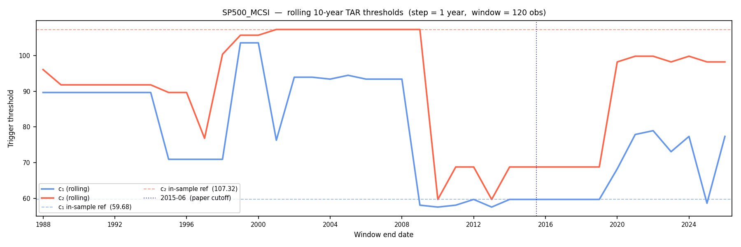
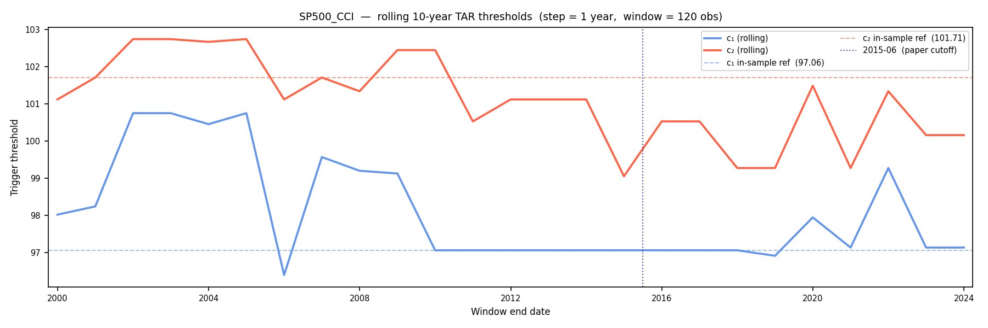

3.3 Data and sample construction
The trigger is the amplitude-adjusted Global OECD Consumer Confidence Indicator (OECD SDMX dataflow DSD_STES@DF_CLI, REF_AREA OECD, subject CCICP; country series are FRED CSCICP03 series, with full codes in the Data source note). It is a GDP-weighted aggregate of the confidence indicators of the 38 OECD member countries, each amplitude-adjusted around 100. The common transformation places the national inputs and the global aggregate on a shared numerical scale. Across the eight OECD-member national CCI series available for panel markets (Netherlands, Greece, Turkey, Spain, Mexico, South Korea, Japan and Switzerland; the panel's other OECD-mapped market, Israel, lacks a downloaded national series), a level of 100 falls at the 38th percentile of one country's own history and the 51st percentile of another's, so the same raw number marks a fairly ordinary reading in some countries and something closer to the edge of typical variation in others. The levels near the estimated tails are less comparable: 97.7 lies between the 4th and 28th percentile and 101.4 between the 63rd and 87th. The transformation therefore supports a common numerical rule, not distributional equivalence or identical economic meaning. Country-specific OECD CCI series are used for the localised estimations in Section 5. Equity data are month-end local-currency price-index closes, so dividends are excluded and returns are nominal monthly log returns.
The panel is built by a screening cascade. From 57 candidate equity index series (one, Colombia, lacks usable data), 24 reject the reverse-Granger null in the four-lag specification and are excluded. Of the remaining 32, 23 retain at least T = 340 monthly observations. Appendix A reports every test. Several large and globally integrated indices fail the screen, including the US indices, FTSE 100, DAX, CAC 40 and ASX 200. This pattern is consistent with feedback from large markets into the GDP-weighted sentiment aggregate, but the screen is a finite-lag predictive test rather than proof of structural exogeneity. The S&P 500 also fails against its own US CCI (F = 3.54, p = 0.008). The panel should therefore be read as the set of long-history indices that pass the maintained reverse-Granger rule, rather than as a representative sample of global equity markets.

3.4 A candidate trigger-domain flag
A global sentiment trigger represents conditions shared across economies. When domestic conditions decouple from the OECD aggregate, the labels may be driven by unrelated global sentiment; they need not default to the middle band. We use a national-global first-difference correlation as a candidate screen for this failure mode. For market $i$ with national CCI $Z_{i,t}$ and global CCI $Z_{g,t}$, compute the correlation of first differences,
$$ρ_{i}=corr\left(ΔZ_{i,t}, ΔZ_{g,t}\right) \left(9\right)$$
First differences remove shared slow trends and focus the statistic on co-movement in sentiment changes. A low $ρ_{i}$ means the global aggregate contains little of the country’s month-to-month sentiment variation. A cutoff near 0.40 identifies candidate decoupling cases: China (0.25), New Zealand (0.29), Greece (0.37) and Turkey (0.38) sit below 0.40, while the rest of the measured panel begins with Czechia (0.415) and Australia (0.435). The small gap between Turkey and Czechia is within the sampling uncertainty of correlations estimated over a few hundred months, so 0.40 is a practical flag rather than a validated classification threshold (Section 5.2, Appendix C).
The workflow has four stages: (1) the reverse-Granger screen; (2) the national-global correlation flag; (3) ex-post alignment against fixed historical episode windows, which can reveal level offsets or crisis-period divergence that the full-sample correlation misses; and (4) country-trigger re-estimation as a diagnostic comparison where the global trigger is questionable. Stage 3 uses historical episode knowledge and is therefore an ex-post interpretive check, not a fully ex-ante selection rule or an outcome-independent standard of correctness. It is not used retrospectively to choose the global CCI over a rival. Country-specific re-estimation replaces the global CCI with the national series and leaves the TAR specification and grid procedure unchanged. It does not establish that the national CCI is structurally exogenous: the local sentiment series and equity index may respond to the same domestic shock. A causal or real-time trigger-selection claim would require separate feedback, release-timing and out-of-sample validation.

3.5 The horizon return test
Section 6 compares forward returns across the estimated low-sentiment, random-walk and high-sentiment bands. For each index-month in the screened panel, the active label is recorded together with the forward log return at horizon h:
$$r_{t,t+h}=p_{t+h}-p_{t}, h∈\{1,3,6,12\}\text{ months} \left(10\right)$$
The convention, fixed in the pipeline, is that the CCI level at the end of month t assigns the label and the forward return cumulates the h monthly log returns strictly after t, with the last h months of each index dropping out for lack of a forward window. Observations are pooled across indices within each label (the index subscript is suppressed in equation (10)), and mean forward returns are compared between labels. The random-walk band is the baseline. If the labels are uninformative, low- and high-sentiment months should be followed by returns indistinguishable from random-walk months. Because the pooled samples differ in size and variance across labels, comparisons use Welch's unequal-variance t-test (Welch, 1947). Japan is excluded from the high-sentiment pool for the reasons established in Section 4.3. A degenerate upper threshold classifies most of its sample in the high-sentiment band even though global sentiment is not economically exceptional for Japan.
Pooling across indices overstates the effective sample where index pairs from the same country appear in the panel (the two Israeli indices, the two Hong Kong indices, the two Indonesian indices and the two Chinese indices (Shanghai and Shenzhen)), and cross-index return correlation reduces the effective sample further. The reported p-values should be read with this in mind; Sections 6.3 and 7.2 report the corrected inference and the remaining caveats.

4 Cross-Market Regime Classification

4.1 Threshold consistency across the panel
Estimating the TAR independently for each of the 23 admissible indices under the single global trigger produces thresholds that cluster: for most of the panel the lower thresholds fall between roughly 97.0 and 98.5 and the upper thresholds between roughly 101.2 and 102.4, straddling the CCI's long-run mean of 100 (Figure 4.1; Table 4.1 reports every pair).
Figure 4.1. Optimal TAR thresholds across the 23 indices, ordered by time in the random-walk band.
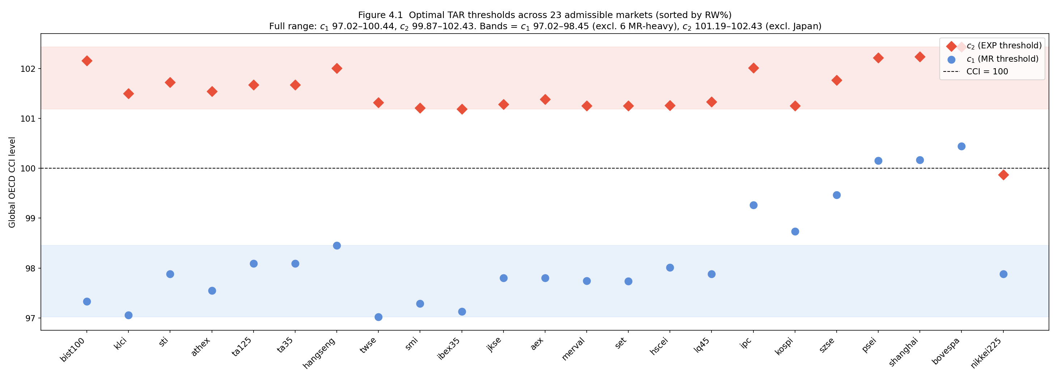
The common amplitude-adjusted CCI gives every index the same observed global conditioning path, which places the fitted shares on a common design and makes them comparable only as outputs of the maintained TAR specification. It does not make the trigger tails distributionally equivalent across national sentiment series: 97.7 maps to the 4th through 28th domestic percentiles and 101.4 to the 63rd through 87th. The threshold cluster shows that many index-specific optimisations choose similar numerical cut-points under the common trigger; it is supporting evidence about the fitted model, not proof that the cut-points have identical economic meaning. The exceptions are indices less closely aligned with global sentiment: South Korea and Mexico place the lower threshold above the cluster, at 98.73 and 99.27; the two Chinese exchanges, the Philippines and Brazil place it higher still, between 99.47 and 100.44; and Japan's degenerate upper threshold of 99.87 sits below the cluster (Section 4.3).
The pooled classification also covers both trigger tails at panel scale: the dot-com years sit above the estimated upper thresholds and are assigned to the high-sentiment band, while the GFC sits below the lower thresholds and is assigned to the low-sentiment band across most of the panel. Full-sample labels and thresholds frozen in mid-2015 agree for 88 percent of index-months when both are evaluated on final-vintage CCI data, with agreement above 94 percent in the threshold-cluster indices and much lower agreement in the outliers (Appendix D). This is a final-vintage stability comparison, not an independent real-time out-of-sample test. The apparent fit advantage is sensitive to the placebo process. With 1,000 simulations, real-index RSS improvement exceeds a Gaussian i.i.d. null, drawn from each market's own historical mean and standard deviation, at the 5 percent level in 9 of 23 indices, but exceeds the harder, more conservative 12-month block-resampled null (Appendix D.5), which preserves real persistence, volatility clustering and fat tails, in only 3 of 23.
That gap is specific to the common-trigger design rather than to the estimator. Applying the identical placebo to Ahmed and Satchell’s own pairings, the real improvement clears the same 12-month block-resampled null for the S&P 500 under the Michigan index (p = 0.006) and for the FTSE 100 under the VIX (p < 0.001), so the estimator does identify a split when the trigger belongs to the market (C54). The S&P 500 does not clear that null under the global CCI (p = 0.094), which is not attributable to market depth since the S&P fails the reverse-Granger screen against this trigger and any endogeneity would bias the test toward passing (C55). Which indices clear is strongly rank-correlated with the realised RSS improvement itself (Spearman ρ = −0.87, p = 5.3 × 10⁻⁸) and unrelated to sample length within the admissible range (ρ = 0.08, p = 0.72), so it should not be read as a market-specific result (C57, C59). Under this common trigger the threshold cluster therefore cannot be defended by claiming that realistic random paths rarely reproduce the fit. Because the grid search always returns a split and no formal threshold-count test is reported, the output is interpreted as a fitted classification map rather than structurally established regime switching.

4.2 Fitted band shares and tail-coverage taxonomy
Random-walk-band shares vary substantially across the 23 screened indices, with most domain-consistent cases lying between approximately 50 and 90 percent. Table 4.1 also contains 94 percent for Turkey and 34 percent for Japan, but neither endpoint is a credible ranking anchor: Turkey's estimate is sensitive to the sample window (Section 5.3), while Japan's follows from a degenerate upper threshold (Section 4.3). The interior conditional comparisons, rather than the raw 34-to-94 span, are the descriptive result, and all shares remain conditional on the maintained trigger and drift specification.
Table 4.1. TAR estimates under the Global OECD CCI, 23 admissible indices, ordered by time in the random-walk band. Stars denote significance at the 10 percent (*), 5 percent (**), and 1 percent (***) levels; coefficients are return-form slopes.
Index | Country | T | c1 | c2 | RW % | Low % | High % | Low-band slope (b_MR) | High-band slope (b_EXP) | Tail coverage
BIST100 | Turkey | 346 | 97.33 | 102.16 | 94.2 | 3.5 | 2.3 | 0.059*** | -0.904*** | Both tails
KLCI | Malaysia | 389 | 97.06 | 101.50 | 90.2 | 1.5 | 8.2 | -1.255*** | -0.274*** | High tail only
STI | Singapore | 436 | 97.88 | 101.72 | 89.2 | 5.7 | 5.0 | -0.004 | -0.313*** | Both tails
ATHEX | Greece | 345 | 97.55 | 101.54 | 88.4 | 4.1 | 7.5 | -0.158*** | -0.270*** | Both tails
TA125 | Israel | 403 | 98.09 | 101.68 | 87.6 | 6.9 | 5.5 | 0.013 | -0.192** | Both tails
TA35 | Israel (TA-35) | 403 | 98.09 | 101.68 | 87.6 | 6.9 | 5.5 | 0.016 | -0.186** | Both tails
HANGSENG | Hong Kong | 436 | 98.45 | 102.01 | 87.4 | 10.1 | 2.5 | -0.136** | -0.865*** | Both tails
TWSE | Taiwan | 346 | 97.02 | 101.32 | 86.7 | 1.7 | 11.6 | -0.799** | -0.152* | High tail only
SMI | Switzerland | 426 | 97.28 | 101.21 | 86.4 | 2.8 | 10.8 | 0.070* | -0.179*** | Both tails
IBEX35 | Spain | 394 | 97.13 | 101.19 | 86.0 | 2.0 | 11.9 | -0.760*** | -0.150*** | Both tails
JKSE | Indonesia | 433 | 97.80 | 101.28 | 85.0 | 5.1 | 9.9 | -0.004 | -0.259*** | Both tails
AEX | Netherlands | 403 | 97.80 | 101.38 | 84.6 | 5.5 | 9.9 | 0.031 | -0.111** | Both tails
MERVAL | Argentina | 355 | 97.75 | 101.25 | 82.5 | 5.1 | 12.4 | 0.030** | -0.180** | Both tails
SET | Thailand | 353 | 97.74 | 101.26 | 82.4 | 5.1 | 12.5 | 0.030 | -0.186** | Both tails
HSCEI | Hong Kong (H-shr) | 394 | 98.01 | 101.26 | 82.2 | 6.6 | 11.2 | -0.247** | -0.133** | Both tails
LQ45 | Indonesia (LQ45) | 351 | 97.88 | 101.33 | 80.9 | 7.1 | 12.0 | -0.010 | -0.341*** | Both tails
IPC | Mexico | 414 | 99.27 | 102.01 | 70.3 | 27.1 | 2.7 | -0.020*** | -0.827*** | Both tails
KOSPI | South Korea | 353 | 98.73 | 101.26 | 69.1 | 18.4 | 12.5 | 0.058** | -0.089 | Both tails
SZSE | China (SZSE) | 345 | 99.47 | 101.77 | 57.4 | 37.4 | 5.2 | -0.098** | -0.474*** | Both tails
PSEI | Philippines | 436 | 100.16 | 102.22 | 53.9 | 45.0 | 1.1 | -0.020*** | -0.325 | Both tails
SHANGHAI | China (SSE) | 346 | 100.17 | 102.24 | 52.0 | 46.8 | 1.2 | -0.063*** | -0.361*** | Both tails
BOVESPA | Brazil | 397 | 100.44 | 102.43 | 50.4 | 49.6 | 0.0 | -0.051*** | 0.000 | Low tail only
NIKKEI225 | Japan | 436 | 97.88 | 99.87 | 33.7 | 5.7 | 60.6 | 0.049* | -0.035*** | Both tails
Note to Table 4.1: the Tail coverage column records which fitted trigger tails are materially activated during the historical sample. Both tails means both outer bands occur, High tail only means only the high-sentiment band is materially activated, and Low tail only means only the low-sentiment band is materially activated. The rule applied is: a tail counts as materially activated when its fitted band share exceeds 2.0 percent for the low-sentiment band or 1.0 percent for the high-sentiment band. Under this rule, 20 of the 23 indices activate both tails; KLCI and TWSE activate the high tail only, and BOVESPA the low tail only. The dot-com and GFC episodes provide supporting historical context for those labels but are not the rule that generates them. Japan's Both tails label is mechanical because its high-sentiment share follows from a degenerate upper threshold and is excluded from the horizon test. BOVESPA has no high-sentiment months, so its b_EXP entry of 0.000 records an unidentified slope rather than an estimate. Each index carries its own threshold pair. Cross-index comparison uses the common numerical trigger scale and remains conditional on the maintained specification and the trigger's domain. Stars are conventional standard errors conditional on the grid-selected split; the full-pipeline bootstrap shows that most individual outer-slope intervals include zero. Section 4.2 reports the demeaned high-sentiment-band intercept as the band's mean monthly return.
Figure 4.2. Share of months in the random-walk band under the Global OECD CCI. Japan’s position at the low end of the ordering follows from a degenerate upper threshold (Section 4.3) rather than from an unusually low random-walk share on economic grounds, and the ordering as a whole is specification-sensitive (Section 4.2).
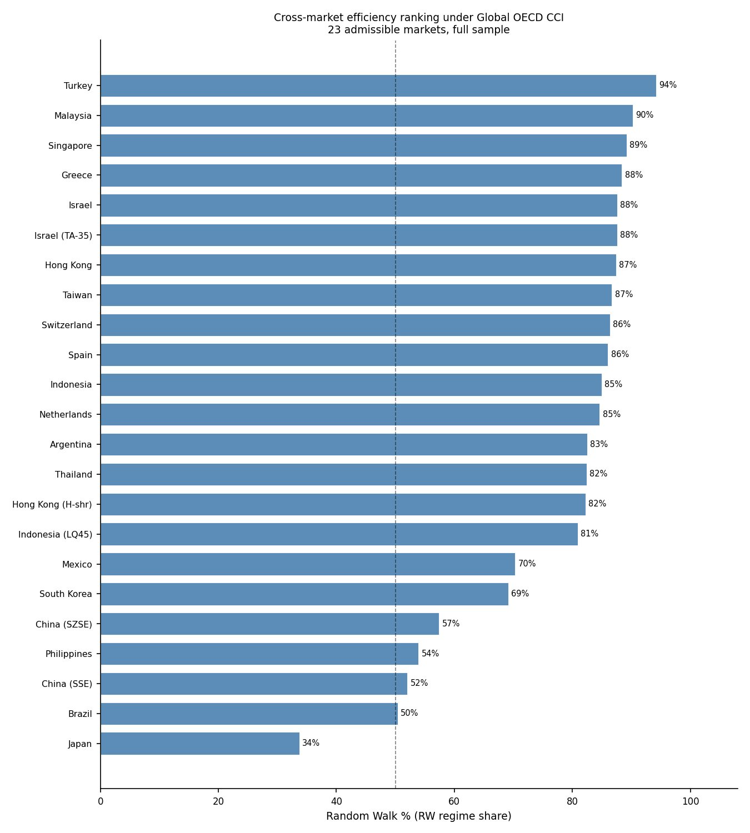
The MR and EXP abbreviations follow Ahmed and Satchell and mark the low-sentiment and high-sentiment bands. Whether each band also carries the dynamics its inherited name implies is an empirical question, and the answer differs across the two. In the low-sentiment band, 11 of the 23 indices show a significant negative return-form slope (correction), five show a significant positive slope, and the rest are indeterminate, so the correction reading holds for about half the panel In the high-sentiment band, no index has a positive slope: every estimated b_EXP is negative, which rules out an explosive autoregressive root, consistent with Ahmed and Satchell's own switching-drift results, where neither original index showed an explosive coefficient either. Brazil has no high-sentiment months, so no slope is identified there, and the 0.000 entry in Table 4.1 marks the empty band. The high-sentiment state is therefore a positional band.
We report each band's intercept as its mean monthly return, estimated with the lagged log price demeaned so the value does not shift when the index is rebased. The high-sentiment band earns a median of +1.03 percent per month (sd 2.96, range -7.4 to +7.4). The drift is modest and noisy, the negative slope offsets part of it, and contemporaneous returns during high-sentiment months are positive in only 12 of the 22 indices that have them.
Two specification comparisons bound how the point-estimate ordering should be read. Counting an outer-band month as dynamically distinguishable from the random-walk specification only where its slope is significant at 5 percent raises the mean random-walk-band share from 76.9 to 80.2 percent and leaves the overall ordering similar (Spearman 0.878), although some indices move materially. By contrast, the ordering is sensitive to the drift specification. Between the switching-drift specification used here and an economically plausible constant-drift alternative, the ranking correlation is 0.42 and the mean share shifts by 9 points. A no-drift specification reorders the panel almost completely but also places several upper thresholds below the trigger's mean and is not treated as a credible benchmark. Dependence of the time-in-state metric on the maintained drift specification is inherited from Ahmed and Satchell; the additional result here is that this sensitivity prevents a specification-invariant ordering in the 23-market panel. The maintained model therefore supports a common set of point estimates, not a specification-invariant ordinal ranking.
The imposed random-walk band receives qualified empirical support. Unrestricted middle-band slopes are negative in 16 indices and positive in seven; six reject zero at the raw 5 percent level, but none survives Benjamini-Hochberg correction at q = 0.05. The median slope is -0.0063, and no multiplicity-adjusted rejection remains. This supports retaining the zero-slope restriction as a panel modelling choice, but it does not convert each index's middle-band share into a separately proven efficiency rate.
Full-pipeline bootstrap re-estimation makes the distinction between aggregate patterns and individual rows sharper. Conditional on the observed CCI path, the median 95 percent interval width is about 1.0 CCI unit for the upper threshold and 13 percentage points for the high-sentiment share. When the trigger and price path are resampled jointly in 24-month blocks, the corresponding median widths rise to 2.7 CCI units and 62 percentage points. The median interval on an individual random-walk share is 67 percentage points, wider than the 60.5-point spread between the lowest and highest fitted shares in the panel, so the estimates cannot separate any two indices with confidence. That comparison should be read with the caveat that Turkey anchors the upper end at 94.2 percent on a full-sample fit that Section 5.3 identifies as a window artifact. Under the same 24-month scheme, and only five high-band slope intervals exclude zero; Brazil also produces an unusually high frequency of degenerate draws. Minimum-regime rules leave all 23 indices feasible and preserve a negative pooled high-sentiment return gap, but their random-walk-share rank correlations with the baseline fall from 0.84 under a 20-observation rule to 0.25 under a 15 percent rule. Exact index shares and fine rankings are therefore uncertain; the defensible panel result is the fitted classification map and its broad sensitivity pattern.
Each index also receives a tail-coverage label describing which fitted bands its history activates. Most indices are both-tailed: under the fixed historical-window convention, the trigger reaches the high-sentiment band during much of the dot-com period and the low-sentiment band during much of the GFC. Malaysia and Taiwan are high-tail-only cases, while Brazil is low-tail-only. These labels describe fitted tail coverage; they do not establish explosive or mean-reverting price dynamics. The labels matter for interpretation, since a random-walk-band share means something different when one tail never fires.
For exposition, the point estimates can be organised into four heuristic groups rather than statistically estimated clusters. Global-stress-aligned markets (Hong Kong, Singapore, Switzerland, Spain, the Netherlands, Israel, Indonesia, Malaysia and Taiwan) have high random-walk shares, with the qualification that Malaysia and Taiwan activate only the high-sentiment tail and Spain carries the crisis-period caveat of Section 5.1. Japan and the Chinese exchanges are grouped as structural-mismatch cases because the episode checks in Section 4.3 show poor alignment with the global trigger. Mexico and Brazil have comparatively large low-sentiment shares, while South Korea and the Philippines accumulate low-sentiment classifications around several stress episodes. These four groupings were constructed by inspecting the fitted results rather than specified in advance, so they describe a pattern in the estimates rather than a validated market taxonomy. The remaining six indices are not individually named here: four (Argentina, the Hong Kong H-shares index, Indonesia's LQ45 and Thailand) share Group 1's high-random-walk, low-sentiment profile but are omitted from this illustrative list rather than excluded for lacking a pattern; Greece and Turkey are treated separately in Section 5, where matched-window and threshold-stability caveats apply to their headline shares. These labels summarise fitted shares and case evidence; they are not formal clusters and do not establish the economic causes of the differences. Dominant-band membership is nonetheless more stable than the ordering it summarises: across the six minimum-regime rules (five, ten and fifteen percent of the sample, and twenty, thirty and forty observations per band) and a constant-drift refit, 22 of the 23 panel indices retain the same dominant band under all seven alternative specifications (C53).The exception is Japan, whose high-sentiment dominance survives three of seven and reverts to random-walk dominance under the tighter minimum-regime rules, which is the behaviour expected of the degenerate threshold documented in Section 4.3. This test establishes that dominant-band membership is a stable feature of the fitted output across the whole panel; it does not validate the four-group taxonomy itself, which was constructed descriptively from the same results. The boundaries between the second, third and fourth groups rest on episode timing rather than band shares and remain expository.

4.3 Three case studies
Hong Kong illustrates the fixed-window positional alignment most clearly. The Hang Seng spends 87 percent of months in the random-walk band, with a brief high-sentiment episode around the 2000 peak and low-sentiment episodes around the 2008 and 2020 troughs (Figure 4.3).
Figure 4.3. Hang Seng under the Global OECD CCI: random walk 87 percent, low sentiment 10, high sentiment 3.
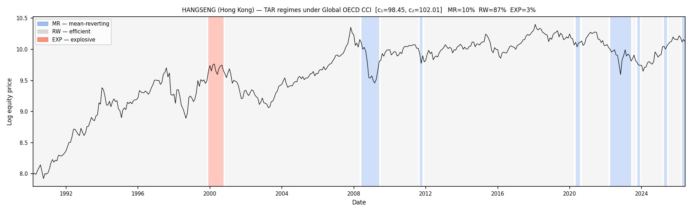
The classification places the Hang Seng in the imposed random-walk band for most months and in the outer bands near major global sentiment extremes.
Japan illustrates a structural mismatch. Sixty-one percent of its months fall in the high-sentiment band and 34 percent in the random-walk band (Figure 4.4). Japan’s own sentiment contribution remains persistently below the OECD average, so the global aggregate lies above Japan’s degenerate upper threshold of 99.87 for much of the sample. The classifier therefore reads ordinary global sentiment as unusually high relative to Japan’s depressed baseline. This is a property of the market-trigger pairing, rather than evidence of an explosive Japanese price process. Japan’s high-sentiment months are excluded from the pooled return test.
Figure 4.4. Nikkei 225 under the Global OECD CCI: random walk 34 percent, low sentiment 6, high sentiment 61. The high-sentiment shading follows from a degenerate upper threshold of 99.87, which sits below the trigger’s long-run mean of 100; it records the divergence of Japanese domestic conditions from the global aggregate and not a sustained period of global euphoria. Japan’s high-sentiment months are excluded from the pooled horizon test in Section 6.
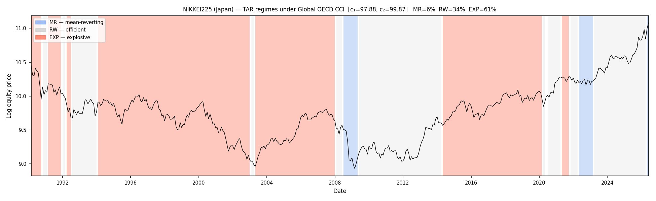
Shanghai illustrates a different alignment failure. The SSE composite spends 47 percent of months in the low-sentiment band and 52 percent in the random-walk band, with a high-sentiment share near zero (Figure 4.5). China’s 2007 to 2008 and 2014 to 2015 boom-bust episodes were domestic, while the global CCI was not in its upper tail. The classifier therefore assigns much of those periods to a low global-sentiment band that does not describe the domestic run-up. Shanghai’s high lower-threshold estimate in Section 4.1 reflects the same mismatch.
Figure 4.5. Shanghai Composite under the Global OECD CCI: random walk 52 percent, low sentiment 47, high sentiment 1.
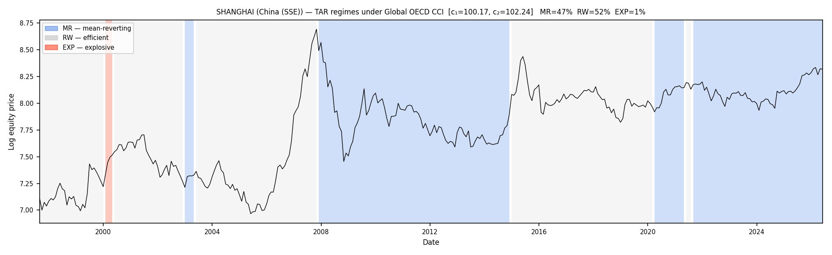

5 The Framework’s Appropriate Domain

5.1 Domestic episodes outside the global trigger's domain
Two results motivate a domain check against the fixed historical episodes used in Section 3. Greece records 88 percent in the random-walk band and 4 percent in the low-sentiment band despite its prolonged sovereign-debt crisis, while Spain's euro-area crisis years largely remain outside the low-sentiment band, which contains 2 percent of IBEX 35 months. These labels are not declared wrong merely because returns were poor. The narrower concern is that independently documented domestic stress episodes barely enter the global trigger's low tail, suggesting that its information set may omit conditions relevant to those markets. Turkey also records 94 percent in the random-walk band, but Section 5.3 shows that figure reflects the estimation window rather than the trigger, so it is set aside here.
The global trigger explains one important failure mode. A severe domestic crisis in an economy with little weight in the GDP-weighted aggregate may leave little trace in the global CCI. The resulting label is then driven by global conditions: the market may remain in the middle band or enter an outer band that describes the aggregate rather than the domestic episode. The classification reflects the information in the trigger rather than the full domestic history.

5.2 The candidate domain flag
The first-difference correlation in equation (9) is a cheap, preliminary screen, not a substitute for actually re-estimating the model with a market's own national trigger, and it flags candidate decoupling cases rather than confirming them. China (0.25), New Zealand (0.29), Greece (0.37) and Turkey (0.38) have the lowest measured correlations, while most measured economies lie between roughly 0.45 and 0.70. These low values show weak measured co-movement with the global aggregate; they do not distinguish omitted domestic information from measurement noise, timing differences or structural breaks, and they do not by themselves prove that the TAR classification fails. Turkey is a false positive for the principal matched-window comparison, while Japan and Spain show failure modes that the full-sample correlation misses, and China's own national trigger reproduces rather than resolves the mismatch (Section 5.3). New Zealand is not re-estimated because the NZX50 provides 281 monthly observations, below the maintained T ≥ 340 admissibility rule; its exclusion is fixed by the design rather than by the localisation result. The screen therefore identifies one source of concern before estimation, not a remedy: country-specific re-estimation is worth attempting only where the national series is long, non-degenerate and assessable against matched historical episodes, and satisfying those conditions does not itself guarantee the mismatch resolves, as China shows. Sub-period interpretive checks and national-trigger re-estimation provide separate evidence, and the domain remains unresolved where no comparable national CCI exists.

5.3 Matched Greek comparison and boundary cases
Greece provides the strongest matched-window evidence. On the sample available for the Greek CCI, the global trigger assigns 83 percent of observations to the random-walk band, while the national trigger assigns 44 percent to the low-sentiment band, 31 percent to the random-walk band and 25 percent to the high-sentiment band. The sovereign-debt years move out of the middle band and into the low-sentiment classification. Re-expressing the national trigger by its percentile rank gives 43.8 percent low sentiment, 31.5 percent random walk and 24.6 percent high sentiment. The fitted partition is therefore insensitive to this numerical re-expression; because the transformation preserves the trigger's ordering, it is not independent evidence that the national CCI is substantively preferable. Nor does it establish that the local trigger is structurally exogenous, since the national CCI and the equity index may both be responding to the same domestic shock; the result is descriptive classification evidence consistent with domain mismatch, not a causal trigger-selection claim. Across the longer global-trigger sample, Greece is 88 percent random walk and 4 percent low sentiment, which shows why the matched window is essential. China (0.25), Greece (0.37) and Turkey (0.38) have the lowest national-global correlations in the admissible panel, but only Greece combines the correlation flag with a matched-window positional reclassification aligned with the fixed crisis window.
Figure 5.1a. ATHEX under the Global OECD CCI, matched window (1997-07 to 2024-01): crisis years remain mostly in the random-walk band (random walk 83 percent). Thresholds are refitted on the matched window rather than cropped from the full-sample estimate, so the split is the one the global trigger selects over the period the Greek CCI covers.
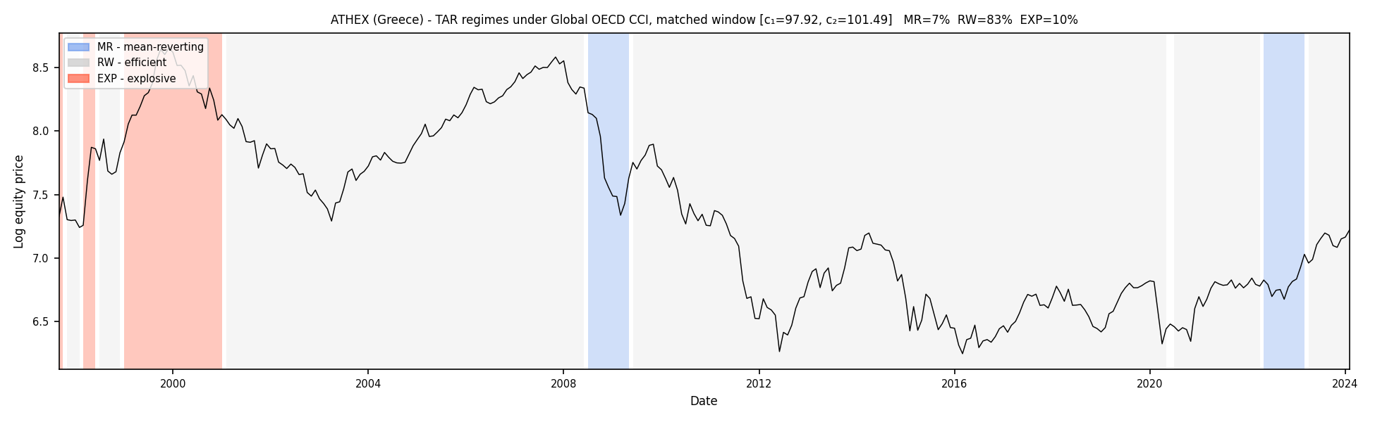
Figure 5.1b. ATHEX under the Greek CCI: crisis years move into the low-sentiment band (low sentiment 44 percent, high sentiment 25).
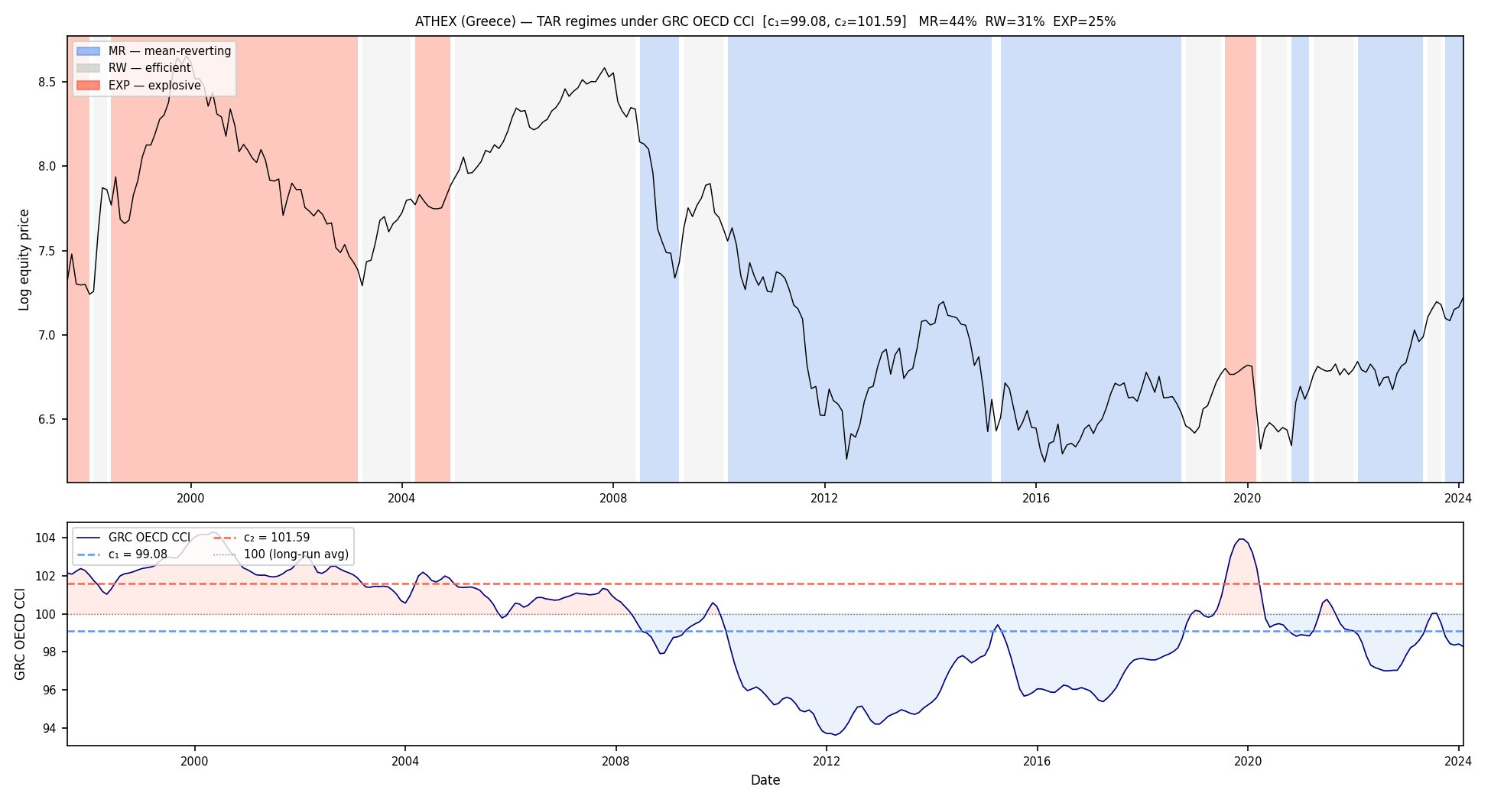
Turkey is a weaker case, and the comparison has to be made carefully (Table 5.1). Under the global trigger over the full sample, Turkey has the largest random-walk-band share, at 94 percent. Under the shorter Turkish-CCI sample, its fitted shares are 48 percent high sentiment, 45 percent random walk and 7 percent low sentiment (Figure 5.2b). Most of that contrast is a sample-window effect rather than a trigger effect. The Turkish series begins in 2004, and re-estimating the global trigger on the same 2004 to 2024 window already puts Turkey at 56 percent high sentiment and 38 percent random walk, close to the country-trigger split; the 94 percent figure comes from the longer 1997 to 2026 window, where the estimated thresholds differ.
Holding the window fixed, the two triggers identify the split about equally: the block-resampled placebo gives p = 0.064 for ATHEX under the global trigger and p = 0.072 under the Greek CCI, while for BIST 100 the national trigger is the weaker of the two (p = 0.254 against 0.074). The national trigger therefore does not identify a split better than the global one; it assigns the same months differently, which is the claim this section makes (C56). Both Chinese exchanges fail the same null under either trigger, and the national trigger is weaker in both cases, consistent with the structural-mismatch reading in Section 4.3.
These comparisons are confined to the matched windows because the Greek and Turkish national series do not begin until 1997 and 2004, and the placebo is sensitive to window length over that range: ATHEX moves from p = 0.004 on its full 345-month sample to p = 0.064 on the 317-month matched window, and BIST 100 from p = 0.025 to p = 0.074 (C57). Within the admissible panel's own range of 345 to 436 observations, sample length and placebo outcome are unrelated. The matched-window global fit is itself degenerate in the sense of Section 4.3: its upper threshold of 99.61 sits below the trigger's long-run mean of 100, so the 56 percent high-sentiment share is produced by threshold placement rather than by exceptional global sentiment. That is a second, mechanical reason to read Turkey as a false positive for the domain argument. Turkey's classification is unstable across windows under either trigger, so country-specific re-estimation adds little once the window is held fixed. The domestic boom-bust the country trigger shows survives deflating the series by Turkish CPI, but it is not something the global trigger misses on a matched sample.

Figure 5.2a. BIST 100 under the Global OECD CCI, matched window (2004-01 to 2024-01): random walk 38 percent, high sentiment 56 percent. Thresholds are refitted on the matched window. The fitted upper threshold of 99.61 sits below the trigger’s long-run mean of 100, so the high-sentiment share here is mechanical in the sense of Section 4.3 rather than a record of domestic euphoria.
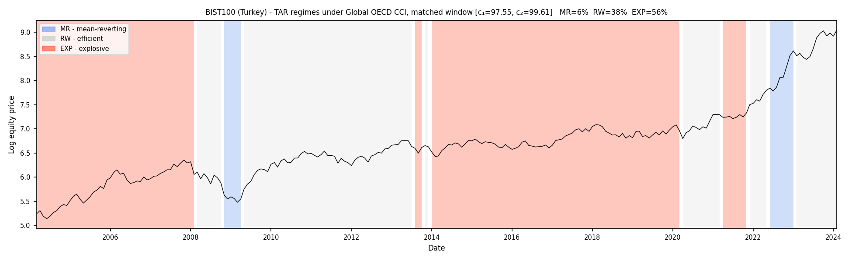
Figure 5.2b. BIST 100 under the Turkish CCI, shorter national-sentiment sample (high sentiment 48 percent).
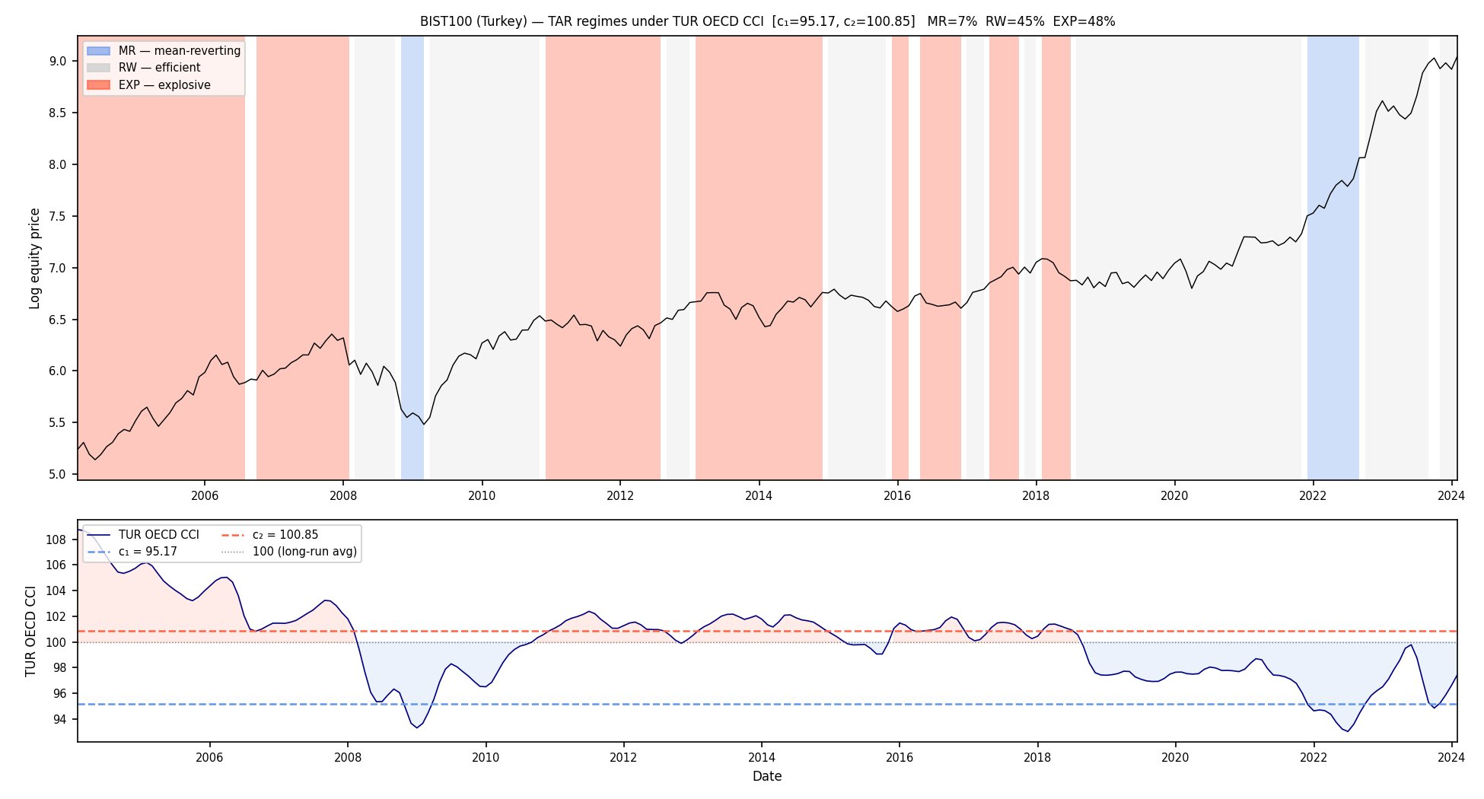
Table 5.1. Matched-window fitted-band shares under global and country CCIs. Only rows for the same index and window identify a trigger contrast; low and high are positional sentiment bands.
Index | Matched window | T | Trigger | Low % | RW % | High %
Greece | 1997-07 to 2024-01 | 317 | Global CCI | 7 | 83 | 10
Greece | 1997-07 to 2024-01 | 317 | Greek CCI | 44 | 31 | 25
Turkey | 2004-01 to 2024-01 | 240 | Global CCI | 6 | 38 | 56
Turkey | 2004-01 to 2024-01 | 240 | Turkish CCI | 7 | 45 | 48
Table 5.2. Standalone global- and country-trigger TAR estimates over each trigger's available sample. Rows with different T are descriptive and are not trigger-effect comparisons; Table 5.1 governs the matched Greece and Turkey interpretation.
Index | Trigger | T | c1 | c2 | Low % | RW % | High % | Low-band slope | High-band slope
ATHEX (Greece) | Global CCI | 345 | 97.55 | 101.54 | 4.1 | 88.4 | 7.5 | -0.158*** | -0.270***
ATHEX (Greece) | Country CCI | 317 | 99.08 | 101.59 | 43.53 | 31.23 | 25.24 | -0.082*** | 0.004
Shanghai (China) | Country CCI | 317 | 100.77 | 104.37 | 70.98 | 27.44 | 1.58 | -0.036*** | -0.770***
SZSE (China) | Country CCI | 316 | 100.77 | 104.38 | 70.89 | 27.85 | 1.27 | -0.026** | -0.594***
BIST 100 (Turkey) | Global CCI | 346 | 97.33 | 102.16 | 3.5 | 94.2 | 2.3 | 0.059*** | -0.904***
BIST 100 (Turkey) | Country CCI | 240 | 95.17 | 100.85 | 6.67 | 45.42 | 47.92 | 0.057** | -0.034***

6 The Horizon Return Test

6.1 Pooled results
Forward returns separate most clearly over twelve months: the average is 14.6 percent after low-sentiment months, 8.0 percent after random-walk months and -7.5 percent after high-sentiment months. Table 6.1 reports the full horizon path across the 23 screened indices. Each index-month is classified using the index's full-sample thresholds and the global CCI. Japan's high-sentiment months are excluded because its upper threshold is degenerate; its other observations remain, and Greece and Turkey enter with the global-trigger labels qualified in Section 5. The observation-level Welch tests are descriptive because returns overlap and indices share calendar labels; Section 6.3 reports the dependence-aware specifications.
Table 6.1. Forward log returns by fitted band, pooled across the 23 admissible indices.
Horizon | After low sentiment (n) | After random walk (n) | After high sentiment (n) | p, low vs RW | p, high vs RW
1 month | +0.69% (1,183) | +0.78% (6,855) | -0.44% (615) | 0.741 | 0.010
3 months | +2.63% (1,163) | +2.23% (6,829) | -1.90% (615) | 0.489 | <0.001
6 months | +7.18% (1,145) | +4.08% (6,778) | -3.34% (615) | <0.001 | <0.001
12 months | +14.60% (1,109) | +8.01% (6,676) | -7.49% (615) | <0.001 | <0.001
Note to Table 6.1: the high-sentiment count is constant across horizons because no included high-sentiment month falls within twelve months of a market’s sample end; the last such month is July 2018 in Spain.
Figure 6.1. Pooled forward log returns by fitted band at all four horizons. The embedded legend retains Ahmed and Satchell's MR/RW/EXP shorthand; here these denote the low-sentiment, random-walk and high-sentiment fitted bands rather than established dynamics.
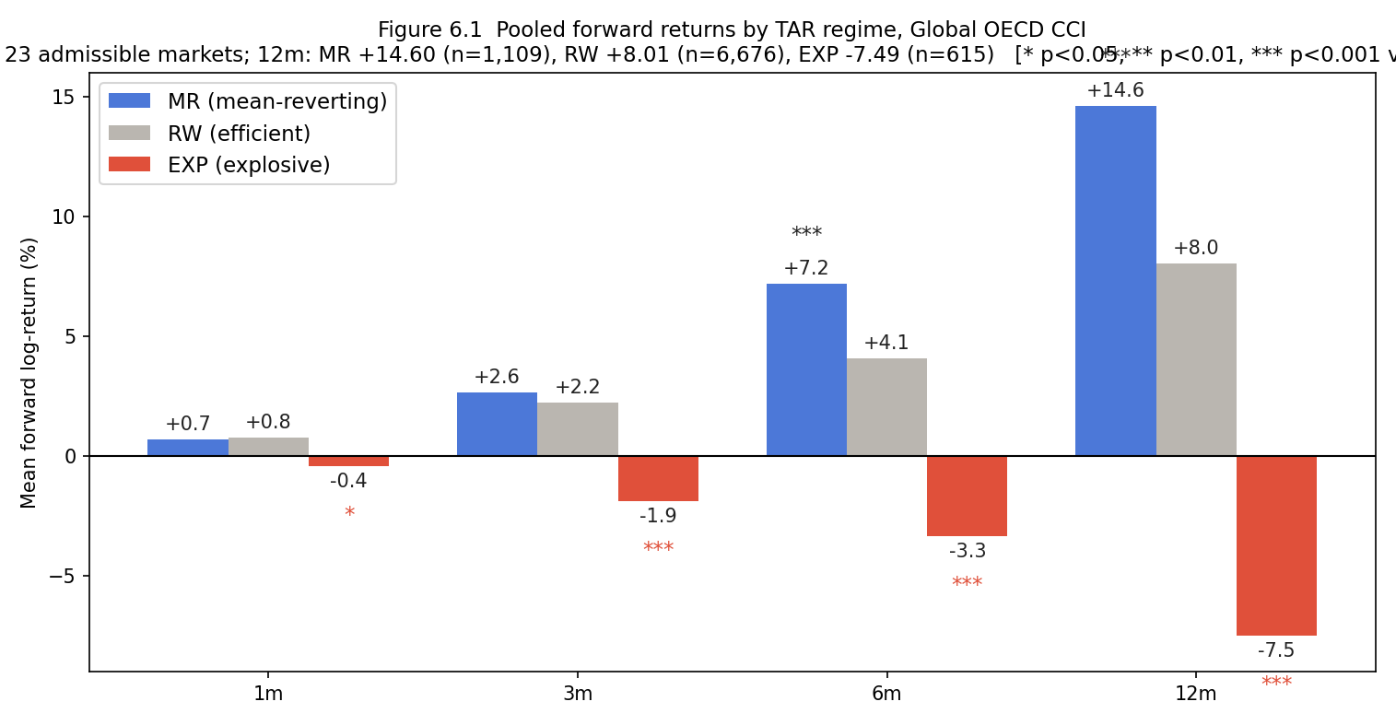
The uncorrected ordering strengthens with the horizon. At one month the low-sentiment and random-walk means are similar, while the high-sentiment mean is lower. At twelve months, low-sentiment months have a mean return nearly twice the random-walk baseline and high-sentiment months have a negative mean. Section 6.3 shows that the high-sentiment discount is the stronger in-sample pattern after dependence corrections, while the low-sentiment magnitude does not survive. The labels describe conditional return distributions; they do not establish a causal normalisation mechanism.
The same sign ordering appears within indices: the low-sentiment mean exceeds the random-walk mean in 19 of 23 indices, and the high-sentiment mean is lower in 20 of the 21 indices with high-sentiment observations after excluding Japan. The corresponding sign-test p-values are 0.0026 and below 0.0001. Because the indices share the same global calendar episodes, these sign tests show cross-index consistency within common events rather than independent replications across time.

6.2 What the distributions add
The per-state distributions of forward returns qualify the means (Figure 6.2).
Figure 6.2. Distribution of twelve-month forward log returns by fitted band, pooled across the 23 admissible indices. The embedded MR/RW/EXP labels denote the low-sentiment, random-walk and high-sentiment fitted bands rather than established dynamics.
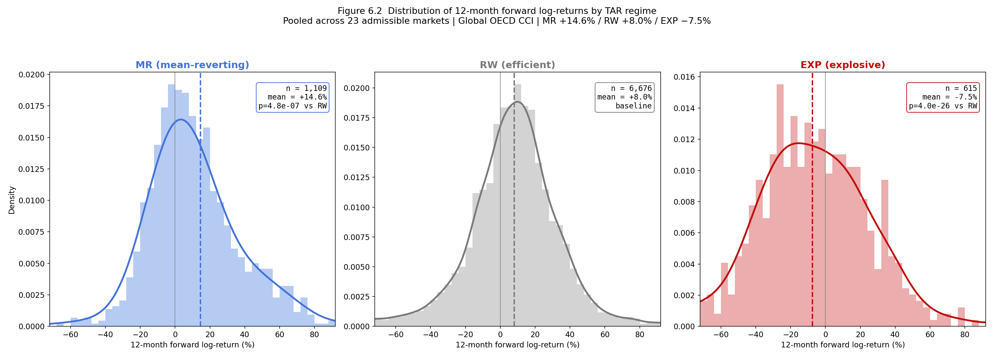
All three distributions overlap heavily. Many random-walk-band months precede large positive returns, and a substantial minority of low-sentiment months precede further losses. The low-sentiment distribution is right-skewed, its mode sitting near +5 percent while the mean sits at +14.6: the difference is tail-driven, produced by deep-trough months whose recoveries are outsized, not by a uniform shift of the distribution. The tail observations date overwhelmingly to 2008-2009 and 2022, with COVID-era months nearly absent, consistent with the sentiment lag documented in Appendix B. The high-sentiment distribution is the widest and flattest of the three, centred below zero but spanning heavy losses to large continued gains, mixing run-ups with crashes.
The labels shift conditional means at long horizons; they do not sort individual months. The returns are also raw rather than risk-adjusted, so part of the low-sentiment return difference may compensate for the risk of buying in a downturn. Any portfolio reading of Table 6.1 should start from these distributions.

6.3 Benchmarks and corrected inference
The forward-return content could come from the trigger alone, with no threshold model. Cutting the pooled CCI at its 10th and 90th percentiles (98.33 and 101.39) gives a twelve-month spread of 22.40 points, against 22.09 between the estimated low- and high-sentiment labels, so a simple sentiment sort reproduces the aggregate spread.
In the full-sample joint regression, the TAR high-band coefficient is -11.28 (p = 0.019) while the fixed above-90th coefficient is -4.36 (p = 0.59). Those individual p-values do not show that the coefficients differ: the direct Driscoll-Kraay Wald test gives p = 0.516 and a 24-month calendar-block bootstrap gives p = 0.618. A recursive, expanding-window comparison using final-vintage CCI produces high-band means of -16.9 percent for TAR and -21.9 percent for the fixed sort, with similar forecast errors; in an encompassing regression both high-band indicators are significant. The two rules therefore contain complementary historical information, but neither encompasses or demonstrably outperforms the other. Because the exercise uses final-vintage CCI, it is recursive rather than a real-time vintage test.
Pooled index-month tests overstate significance because twelve-month windows overlap and every index takes its label from the same trigger in the same calendar months (Hansen and Hodrick, 1980; Petersen, 2009). The moving-block bootstrap resamples complete cross-sectional month vectors in blocks of 12, 24 and 36 months, preserving within-block serial dependence and contemporaneous cross-index dependence. The reported results use 1,000 replications and calculate p-values from the bootstrap standard error; thresholds and labels are held fixed, so this inference is conditional on the estimated classification. A Driscoll-Kraay regression with eleven lags provides an analytic cross-check. This fixed-label moving-block (Künsch, 1989) design is the primary dependence correction for both tails because it preserves the overlapping-window structure directly.
The low-sentiment-minus-random-walk gap of 6.6 points is not significant (bootstrap p = 0.21, 0.31 and 0.35; Driscoll-Kraay p = 0.18). The high-sentiment-minus-random-walk gap of -15.5 points is marginal to significant (bootstrap p = 0.083, 0.049 and 0.026; Driscoll-Kraay p = 0.040). Point estimates are unchanged.
A separate full-pipeline bootstrap addresses generated-classification uncertainty by re-estimating every index's complete threshold search in each draw. Resampling complete cross-sectional calendar-month vectors gives a mean low-sentiment-minus-random-walk gap of +8.18 points with a 95 percent interval of +2.52 to +15.41, and a high-sentiment-minus-random-walk gap of -10.88 with an interval of -18.23 to -4.32. This design preserves contemporaneous cross-index dependence and threshold estimation but does not impose the same moving-block treatment of serial overlap as the fixed-label bootstrap. It therefore complements rather than replaces the dependence corrections above. Accordingly, the fixed-label moving-block and Driscoll-Kraay results remain the primary dependence-aware inference for both tails. The high-sentiment gap is negative under both layers of inference; the low-sentiment magnitude changes status across them and is treated as inference-dependent.
An episode-level calculation removes overlapping windows within each index by treating each contiguous high-sentiment spell as one observation. The 30 spells outside Japan average 20.5 months and have a mean twelve-month excess of -15.0 points relative to each index's random-walk baseline, with 26 of 30 negative. Cross-index dependence remains because 29 spells occur during the 1997 to 2000 global euphoria. Collapsing the spells to five calendar-year clusters gives a mean of -18.3 points (t = -3.16, p = 0.034). Four clusters belong to the same euphoria, so even this calculation overstates independence and the effective number of separate episodes is closer to two. The p-value is therefore descriptive evidence of cross-index consistency within the observed euphoria; it is not inference across independent euphoric episodes.
Figure 6.3. Episode-level excess returns for the 30 high-sentiment spells.
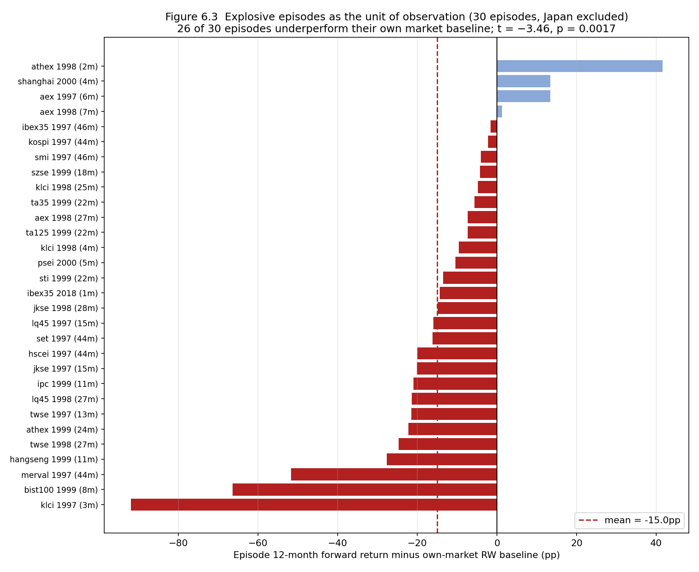
Excluding the COVID window of January 2020 to December 2021 does not account for the low-sentiment result. Of 552 excluded index-months, 101 are classified low sentiment and none is classified high sentiment; removing them raises the pooled twelve-month low-sentiment mean from 14.60 to 14.92 percent rather than lowering it (C58). A circular-shift permutation shows the labels are aligned with the reversals within the panel rather than placed by chance. Re-timing each index's high-sentiment spells at random, which preserves every index's own return dynamics and breaks only the labels' calendar alignment, reproduces the observed discount in none of 5,000 draws (p < 0.0002). Because nearly every spell shares the 1997 to 2000 episode, this establishes alignment within that event; it does not extend the pattern to euphoric episodes the sample does not contain.
The discount is not attenuated by the index's own recent return. Adding each index's trailing twelve-month return to the forward-return regression leaves the high-sentiment coefficient unchanged (-14.07 to -14.06) and the trailing term insignificant (p = 0.55). This controls for one linear summary of past returns, not for volatility, nonlinear momentum or a latent global factor. Under dependence-robust errors the high-sentiment coefficient is marginal (p = 0.06), and the episode calculation is concentrated in the same 1997 to 2000 event. The control therefore narrows one return-feedback explanation without creating independent-era identification or upgrading the result beyond a historically bounded association.
Three checks examine whether sample composition drives the episode estimate. Excluding the seven spells that open during the Asian financial crisis onset leaves the mean excess at -11.45 points; the excluded spells average -26.8 points, so the Asian crisis increases the magnitude without accounting for the full estimate. The corresponding unclustered p = 0.017 remains descriptive because the retained spells are still concentrated in one global event. Keeping one index per country leaves the mean at -14.9 points; its unclustered p = 0.006 has the same limitation. Returning Japan's excluded high-sentiment months to the pooled monthly comparison moves the twelve-month mean from -7.5 to -6.1 points, so the exclusion does not create the negative point estimate.
Minimum-regime constraints do not reverse the pooled return ordering, but they show that its magnitude and episode composition depend on the threshold rule. Requiring 5, 10 or 15 percent in every fitted band leaves all 23 indices feasible and changes the high-sentiment-minus-random-walk gap from -15.5 points at baseline to -13.2, -7.7 and -5.1; absolute minima of 20, 30 and 40 observations produce -12.6, -8.8 and -7.7. The high-sentiment episodes remain concentrated in 1997 to 2000 under the looser rules and become more diffuse when a large high band is forced. This is robustness of the negative sign, not of the exact magnitude or historical allocation.
The discount is not confirmed outside its era. Dropping the 1997 to 2000 window leaves a single episode (Spain, 2018), too few to test. Applying thresholds frozen in mid-2015 to post-2015 months, the 76 high-sentiment index-months (from four calendar years and four indices) carry a gap of -9.8 points that does not survive dependence correction (bootstrap p = 0.22, Driscoll-Kraay p = 0.19). The post-2015 sample contains no comparable global euphoria, so it supplies a weak test of cross-era replication rather than a failed one.
The analysis does not use a complete real-time release calendar. To bracket publication timing, the CCI is lagged by one and two months and the thresholds are re-estimated. At lag zero the high-sentiment-minus-random-walk gap is -16.17 points; the timing exercise uses its own common timing sample and re-estimates thresholds, so this value differs slightly from the -15.5-point fixed-label estimate above. Its Driscoll-Kraay p-value is 0.020, with block-bootstrap p-values of 0.046, 0.017 and 0.008 for 12-, 24- and 36-month blocks. At one month the gap is -15.90 (Driscoll-Kraay p = 0.025; block p-values 0.055, 0.044 and 0.025). At two months it attenuates to -12.26 and no longer rejects under the block bootstrap (p = 0.103, 0.093 and 0.077), despite a Driscoll-Kraay p-value of 0.049. The evidence therefore supports robustness to a one-month timing allowance, not to an arbitrary publication lag or to real-time data revisions.
The low-sentiment return difference is not robust across inference designs. It is absent from the fixed-label moving-block and Driscoll-Kraay comparisons and from the frozen-window exercise, while the full-pipeline calendar-month bootstrap that re-estimates thresholds produces a positive interval. These procedures address different uncertainty sources, so the latter does not overturn the former. The low-sentiment months also occupy only nine calendar clusters. The remaining consistent evidence is directional: the low-sentiment mean exceeds the random-walk-band mean in 19 of 23 indices (p = 0.003). The difference is therefore an in-sample regularity whose magnitude is method-dependent, not a settled panel effect.
The two tails differ in evidential strength. The high-sentiment discount is the stronger in-sample pattern: its negative sign survives fixed-label dependence corrections, full-pipeline threshold re-estimation, minimum-band rules and a one-month publication lag. The recursive horse race shows that the TAR label retains information alongside a fixed upper-tail indicator, but the direct Wald test and similar predictive errors do not support a claim of superiority over the simple sentiment rule. The fixed-tail benchmark therefore answers an attribution question specific to return forecasting: the return association is not unique to the estimated TAR boundary, while the estimated label retains historically bounded content alongside the simpler rule.
This is a claim about forecasting content, not about whether the estimated split reflects genuine regime structure; the same placebo design clears the block-resampled null decisively for both of Ahmed and Satchell's original pairings (p = 0.006 and p < 0.001; Section 4.1, C54), so the estimator identifies real structure when the trigger matches the market, and the common-trigger design is what limits its forecasting edge here. This is consistent with the wider sentiment literature, which finds comparable return predictability using continuous sentiment measures without an estimated regime classification (Baker and Wurgler, 2006; Schmeling, 2009; Vuong and Suzuki, 2022); the fixed-tail result suggests the estimated boundary is not required to recover that content here either. Its identifying variation comes almost entirely from the 1997 to 2000 euphoria, so the result is strongest as a description of that event and is not validated across independent euphoric eras. The low-sentiment sign is consistent across indices, but its magnitude changes inferential status across correction schemes.

7 Discussion
The common-trigger panel shows what an international implementation of the state-based metric can and cannot compare. The common global CCI path and maintained TAR design produce a common-design set of fitted positional classifications across 23 screened indices. The middle-band restriction is not rejected after multiplicity correction on the fitted bands, and largely holds under a price-blind re-test as well, save one exception (Brazil), but the trigger tails occupy different national percentiles, individual shares are imprecise under block re-estimation, and minimum-regime and drift choices reorder the panel. The block placebo and absence of a formal threshold-count test also prevent treating the fitted partitions as structurally established regimes. The instability of fine ranks is an empirical boundary rather than an empty result: the defensible output is a common-design map of fitted positions, tail coverage and mismatch cases, with heuristic groups used for exposition rather than a league table of absolute market efficiency.
The matched-window Greece comparison supplies the strongest evidence on trigger domain. The sovereign-debt crisis remains largely in the global-trigger random-walk band and moves into the low-sentiment band under the Greek CCI; a percentile-normalised national trigger produces almost the same shares. This shows that the fitted partition is insensitive to that numerical re-expression, but it is not independent validation because percentile ranking largely preserves the trigger's ordering. The comparison is consistent with information-domain mismatch but does not prove that the national CCI is causally prior, because local sentiment and equities may share the same crisis shock. The national-global correlation helps locate candidate decoupling, but Turkey, Japan, Spain and China prevent it from being treated as a validated cutoff rule. Greece is a matched-window case study consistent with domain mismatch; the broader established result is that classification depends on the market-trigger pairing, not that the proposed screen automatically selects a structurally exogenous local trigger.
The return analysis gives the classifications asymmetric historical content. High-sentiment months precede unusually weak twelve-month returns across many indices within the 1997 to 2000 euphoria, and the negative sign survives several forms of dependence, threshold and band-size uncertainty. A recursive encompassing regression leaves both the TAR high band and a fixed CCI upper tail informative, while the formal coefficient comparison cannot distinguish them. The inability to distinguish the two coefficients is itself an attribution result: the evidence does not support assigning the historical spread uniquely to TAR threshold estimation. Both indicators retain conditional content when entered together, but the evidence does not show that the TAR outperforms the simpler rule. The TAR's defensible contribution therefore lies primarily in conditional state classification and trigger-domain diagnosis, while its return labels provide a historically bounded characterisation rather than a superior forecasting method. The low-sentiment sign is consistent across indices but its magnitude is inference-dependent. The three results form one argument: the common panel creates a conditional comparison, the matched Greek case documents a domain mismatch, and horizon returns assess the historically bounded economic content of the resulting classifications.

7.1 Abandoned composite-trigger approaches
PCA-based composites were evaluated because no single global series passes every screen for every index. The initial construction combined the CCI, VIX and business confidence after orthogonalising each component against return lags. It appeared to pass the four-lag reverse-Granger screen for all 23 indices, but that result was mechanical once the orthogonalisation window exceeded the test horizon. Under BIC-selected orthogonalisation and a test horizon extending beyond that window, the same composite passed for only three indices. The approach was therefore set aside rather than treated as an identification improvement.
Alternative composites did not resolve the trade-off. A combination of the CCI with the economic policy uncertainty index of Baker, Bloom and Davis (2016) improved reverse-Granger coverage to 18 of 23 indices at a longer horizon but covered both trigger tails in only 10 of 23. A leave-one-out global CCI would remove the home country's direct mechanical contribution, but common shocks and international feedback would remain. These exploratory constructions are documented as abandoned or future specifications; none enters the main results or constitutes an additional contribution.

7.2 Limitations
The general dependence of the time-in-state metric on the maintained drift specification is inherited from Ahmed and Satchell, whose own application changes materially across drift specifications. The 23-market ordering reported here is nevertheless this paper's responsibility: Section 4.2 shows that both its levels and ordering change under an economically plausible constant-drift specification and under minimum-band rules. Table 4.1 is therefore comparative within the maintained switching-drift model and does not measure absolute market attributes. The common amplitude scale is also only numerical: levels near the estimated trigger tails occupy wide ranges of domestic percentiles.
The reverse-Granger screen is linear and finite-lag; non-rejection does not establish structural exogeneity or eliminate common shocks. Country-trigger re-estimation is descriptive for the same reason and may reflect a shared domestic shock rather than causal priority of sentiment. The frozen and recursive exercises use final-vintage OECD data and are therefore pseudo-out-of-sample stability comparisons rather than real-time forecasts. The 56 screening tests and per-index coefficient tests create multiplicity; Benjamini-Hochberg correction leaves 19 of 24 screening rejections and 30 of 33 coefficient rejections, while individual stars remain descriptive.
The full-pipeline bootstrap quantifies uncertainty from the grid-selected split, but its answer depends on what is held fixed. Wild resampling conditional on the observed CCI path yields moderately narrow threshold and high-band-share intervals; moving-block resampling of the trigger and price path yields much wider share intervals, and only five to six of 23 high-band slope intervals exclude zero. Brazil is particularly unstable because many bootstrap draws are degenerate. The pooled return gaps are more stable than the individual rows, but the calendar-month full-pipeline bootstrap does not replace the serial-dependence corrections for overlapping returns. A formal threshold-count test remains necessary before making stronger structural claims, and a vintage-consistent design before real-time ones.
The forward-return outcomes are nominal local-currency price-index returns. They exclude dividends, risk-free rates, currency conversion and factor adjustment. The reported gaps therefore describe conditional price-return differences rather than investable alpha or abnormal returns. Total-return, excess-return, common-currency and risk-adjusted specifications are required before the return evidence is given a portfolio interpretation.
Temporal concentration is a limitation of the present return extension: 29 of 30 high-sentiment spells occur in 1997 to 2000, and the sparse post-2015 sample does not confirm the pattern. Contribution 3 therefore establishes historically bounded label content, not cross-era generality. This boundary arises from the present trigger, panel and forward-return design; it is not inherited from Ahmed and Satchell's original application.
Under the common trigger, the expanded placebo does not support a broad claim that the fitted TAR improvement is distinct from realistic random variation. The same placebo applied to Ahmed and Satchell's own market-trigger pairings does clear the 12-month block-resampled null (C54), so the limitation is a property of the common-trigger implementation and not of the estimator. With 1,000 simulations per index, the real RSS gain exceeds an i.i.d. null at the 5 percent level in 9 of 23 indices, but it exceeds a 12-month block-resampled null in only 3. The block null better preserves volatility clustering and heavy tails. The fitted partitions remain available for common-design descriptive comparisons and the historically bounded return exercise, but the threshold fit itself cannot be treated as structural validation.
The unrestricted middle-band check is more favourable to the maintained restriction: six raw 5 percent rejections become zero after Benjamini-Hochberg correction on the fitted bands. A price-blind version of the same check, which removes the fitted boundary's dependence on flatness, finds more evidence against the restriction rather than less, eight raw rejections and one surviving correction (Brazil; Appendix D.3), so the restriction is retained as a panel modelling choice with one identified exception rather than as an unchallenged assumption, while individual stars remain descriptive.
The horizon test pools across indices whose returns are correlated, and the panel includes same-country index pairs; Section 6.3 reports the block-bootstrap correction. The episode-coverage check (Appendix B) is sensitive to how episode windows are defined, and COVID-era coverage is near zero because sentiment moved with a lag relative to the equity crash, so the both-tails interpretation leans on the dot-com and GFC episodes. Because this check is ex post and candidates do not all have equal panel histories, it cannot serve as an outcome-independent correctness criterion or prove CCI superiority.

7.3 Extensions
Extensions required before stronger structural, real-time or portfolio claims include a complete CCI release and vintage calendar, total-return and risk-adjusted outcomes, common-currency specifications, a formal threshold-count test and a leave-one-out global trigger for large markets. Bootstrap confidence intervals, minimum-band trimming and the recursive fixed-percentile comparison are reported here and are no longer future work. Country-specific reruns remain useful for candidate decoupling cases only where the national series is long, non-degenerate and assessed on matched historical episodes. Individual equities are a later application once trigger selection and real-time inference are resolved.

8 Conclusion
Ahmed and Satchell (2018) replace a sample-wide efficiency verdict with a trigger-driven state classification. This paper provides the first systematic international common-trigger application of that procedure, using a screened panel of 23 equity indices under the amplitude-adjusted Global OECD CCI. Holding the trigger and TAR specification fixed creates a common estimation design, and the middle-band restriction is not rejected after multiplicity correction, including under a price-blind re-test, save one exception (Brazil). That result does not make the estimated shares absolute attributes: the trigger tails have different national-percentile meanings, block-bootstrap share intervals are wide, drift and minimum-band choices alter the ordering, and the block placebo does not establish structural threshold switching under the common trigger. The inability of the point estimates to sustain fine ranks is itself informative about the metric's scale of use. The cross-index contribution is a conditional fitted classification map and sensitivity profile that supports heuristic grouping and case comparison, not a precise efficiency ranking or proof of three structural regimes in every index.
The trigger-domain analysis explains why that scope matters. On a matched window, the global CCI assigns 83 percent of Greek observations to the random-walk band and leaves much of the sovereign-debt crisis there. The Greek CCI instead assigns 44 percent to the low-sentiment band, reclassifying the crisis years into that positional state, and a percentile-normalised Greek trigger produces nearly identical shares. Because percentile ranking largely preserves the trigger's ordering, that rerun is a numerical-scale sensitivity check rather than independent validation. Greece therefore documents one matched-window positional contrast consistent with domain mismatch. The historical alignment does not prove correction dynamics, and national sentiment and equities may respond to the same crisis shock, so this is not a causal trigger-selection result. The national-global correlation helps identify candidates for the check, but the boundary cases show that it is not a validated cutoff or an automatic remedy.
The horizon-return analysis adds a historically bounded economic characterisation of the resulting bands. Average twelve-month returns are 14.6 percent after low-sentiment months, 8.0 percent after random-walk months and -7.5 percent after high-sentiment months. The negative high-sentiment sign survives the primary fixed-label dependence corrections and separately remains negative under full threshold re-estimation, minimum-band rules and a one-month publication lag. In recursive final-vintage estimates, both the TAR high band and a fixed upper-tail CCI rule retain information, while a direct Wald test cannot distinguish their coefficients. The benchmark shows that the return association is not unique to the TAR and locates the framework's contribution in classification and trigger-domain diagnosis rather than forecasting superiority. Because 29 of 30 spells occur during the 1997 to 2000 euphoria and the sparse post-2015 sample does not confirm the relationship, the evidence is a cross-index regularity within one historical event rather than a general forecasting law. The low-sentiment sign is consistent across indices, but its magnitude is inference-dependent; nominal local-currency price-index outcomes are not abnormal returns or investable alpha.
The paper's three contributions are connected but differ in strength. The common-trigger panel establishes a common-design fitted classification map and sensitivity profile, not structural regimes or a precise ranking. The Greece comparison documents a matched-window positional contrast consistent with domain mismatch, not a universal diagnostic rule or causal remedy. The return analysis establishes historically bounded label content, not superiority over a simple sentiment tail or cross-era predictability. Together they provide an empirical evaluation of the framework's international reach, an observable trigger-domain failure mode and its bounded economic content. That bounded result is the contribution: it identifies the scale at which the framework travels, one circumstance in which trigger domain fails, and where the return content belongs once a simple sentiment benchmark is included.

Appendix A. Reverse-Granger screening detail
Specification (8) regresses the differenced global CCI on four own lags and four lags of each index's log return, followed by an F-test of the return lags. An index receives a screening pass when p > 0.05; this is non-rejection, not proof of structural exogeneity. Table A.1 reports all 57 candidate indices (32 pass, 24 reject, one without data). For the composite investigation in Section 7.1, the test lag is the maximum of the BIC-selected Granger lag and the largest orthogonalisation lag plus four.
Table A.1. Reverse-Granger screening results: equity returns predicting the differenced global CCI.
Index | Country | T | F | p | Screen
SP500 | USA | 437 | 5.60 | 0.0002 | FAIL
NASDAQ | USA (NASDAQ) | 437 | 3.77 | 0.0050 | FAIL
DJIA | USA (DJIA) | 413 | 4.80 | 0.0009 | FAIL
RUT | USA (Small-Cap) | 437 | 3.98 | 0.0035 | FAIL
RUI | USA (Large-Cap) | 402 | 5.32 | 0.0003 | FAIL
SP400 | USA (Mid-Cap) | 437 | 4.09 | 0.0029 | FAIL
WILSHIRE5000 | USA (Total Mkt) | 437 | 5.79 | 0.0002 | FAIL
TSX | Canada | 437 | 4.26 | 0.0022 | FAIL
IPC | Mexico | 415 | 1.82 | 0.1250 | PASS
BOVESPA | Brazil | 398 | 1.28 | 0.2755 | PASS
IPSA | Chile | 210 | 0.97 | 0.4226 | PASS
COLCAP | Colombia | - | - | - | no data
MERVAL | Argentina | 356 | 0.48 | 0.7481 | PASS
EUROSTOXX50 | Eurozone | 231 | 4.07 | 0.0034 | FAIL
FTSE100 | UK | 437 | 2.49 | 0.0426 | FAIL
FTMC | UK (Mid-Cap) | 437 | 4.82 | 0.0008 | FAIL
DAX | Germany | 437 | 3.58 | 0.0069 | FAIL
MDAX | Germany (MDAX) | 364 | 3.82 | 0.0047 | FAIL
CAC40 | France | 435 | 4.03 | 0.0032 | FAIL
IBEX35 | Spain | 395 | 2.28 | 0.0600 | PASS
SMI | Switzerland | 427 | 1.46 | 0.2130 | PASS
AEX | Netherlands | 404 | 1.41 | 0.2311 | PASS
FTSEMIB | Italy | 342 | 3.47 | 0.0086 | FAIL
ISEQ | Ireland | 347 | 2.99 | 0.0190 | FAIL
ATHEX | Greece | 346 | 1.74 | 0.1416 | PASS
BEL20 | Belgium | 422 | 4.81 | 0.0008 | FAIL
ATX | Austria | 403 | 3.87 | 0.0043 | FAIL
PSI20 | Portugal | 158 | 2.19 | 0.0728 | PASS
OMXSTOCKHOLM | Sweden | 211 | 2.47 | 0.0459 | FAIL
OMXHELSINKI | Finland | 159 | 3.73 | 0.0064 | FAIL
OMXCOPENHAGEN | Denmark | 114 | 1.70 | 0.1552 | PASS
OSEAX | Norway | 159 | 2.62 | 0.0374 | FAIL
BUX | Hungary | 291 | 1.47 | 0.2102 | PASS
TA125 | Israel | 404 | 1.21 | 0.3046 | PASS
TA35 | Israel (TA-35) | 404 | 1.43 | 0.2222 | PASS
BIST100 | Turkey | 347 | 0.82 | 0.5108 | PASS
NIKKEI225 | Japan | 437 | 1.08 | 0.3677 | PASS
TOPIX | Japan (TOPIX) | 221 | 0.28 | 0.8923 | PASS
SHANGHAI | China (SSE) | 347 | 0.16 | 0.9606 | PASS
CSI300 | China (CSI 300) | 63 | 0.21 | 0.9339 | PASS
SZSE | China (SZSE) | 346 | 0.01 | 0.9996 | PASS
HANGSENG | Hong Kong | 437 | 1.26 | 0.2869 | PASS
HSCEI | Hong Kong (H-shr) | 395 | 1.41 | 0.2308 | PASS
KOSPI | South Korea | 354 | 0.20 | 0.9377 | PASS
KOSDAQ | South Korea (KQ) | 308 | 0.20 | 0.9369 | PASS
NIFTY50 | India | 225 | 2.64 | 0.0348 | FAIL
KSE100 | Pakistan | 291 | 1.77 | 0.1359 | PASS
STI | Singapore | 437 | 0.94 | 0.4390 | PASS
TWSE | Taiwan | 347 | 0.59 | 0.6720 | PASS
JKSE | Indonesia | 434 | 0.50 | 0.7388 | PASS
LQ45 | Indonesia (LQ45) | 352 | 0.60 | 0.6660 | PASS
KLCI | Malaysia | 390 | 0.33 | 0.8547 | PASS
SET | Thailand | 354 | 0.39 | 0.8175 | PASS
PSEI | Philippines | 437 | 0.72 | 0.5784 | PASS
ASX200 | Australia | 403 | 6.32 | 0.0001 | FAIL
AORD | Australia (All) | 437 | 6.75 | 0.0000 | FAIL
NZX50 | New Zealand | 281 | 2.16 | 0.0736 | PASS
Note to Table A.1: the sample size T reported here is the number of observations used in the reverse-Granger screening regression. The estimation sample in Table 4.1 is T minus one for each index because differencing log prices to form returns removes the first observation. All sample-size differences between the two tables follow from this offset and do not reflect a data discrepancy.

Appendix B. Historical episode coverage
Share of episode months classified in the pre-designated positional band (dot-com to the high-sentiment band; GFC and COVID to the low-sentiment band), by index. Coverage is sensitive to the episode-window definitions, and COVID-era coverage is near zero because survey sentiment lagged the equity crash. The table is reported for transparency; it is not primary evidence (Figure B.1).
Table B.1. Share of episode months classified in the pre-designated positional band.
Index | Dot-com (high %) | GFC (low %) | COVID (low %)
BIST100 | 20.5 | 57.1 | 0.0
KLCI | 74.4 | 0.0 | 0.0
STI | 56.4 | 100.0 | 0.0
ATHEX | 66.7 | 85.7 | 0.0
TA125 | 56.4 | 100.0 | 0.0
TA35 | 56.4 | 100.0 | 0.0
HANGSENG | 28.2 | 100.0 | 33.3
TWSE | 89.7 | 0.0 | 0.0
SMI | 97.4 | 57.1 | 0.0
IBEX35 | 97.4 | 28.6 | 0.0
JKSE | 92.3 | 100.0 | 0.0
AEX | 87.2 | 100.0 | 0.0
MERVAL | 94.9 | 85.7 | 0.0
SET | 94.9 | 85.7 | 0.0
HSCEI | 94.9 | 100.0 | 0.0
LQ45 | 89.7 | 100.0 | 0.0
IPC | 28.2 | 100.0 | 66.7
KOSPI | 94.9 | 100.0 | 33.3
SZSE | 46.2 | 100.0 | 66.7
PSEI | 12.8 | 100.0 | 66.7
SHANGHAI | 10.3 | 100.0 | 66.7
BOVESPA | 0.0 | 100.0 | 100.0
NIKKEI225 | 100.0 | 100.0 | 0.0
Figure B.1. Share of episode months classified in the pre-designated positional band, by index and episode. The plot's EXP/MR shorthand denotes the high- and low-sentiment positional bands.
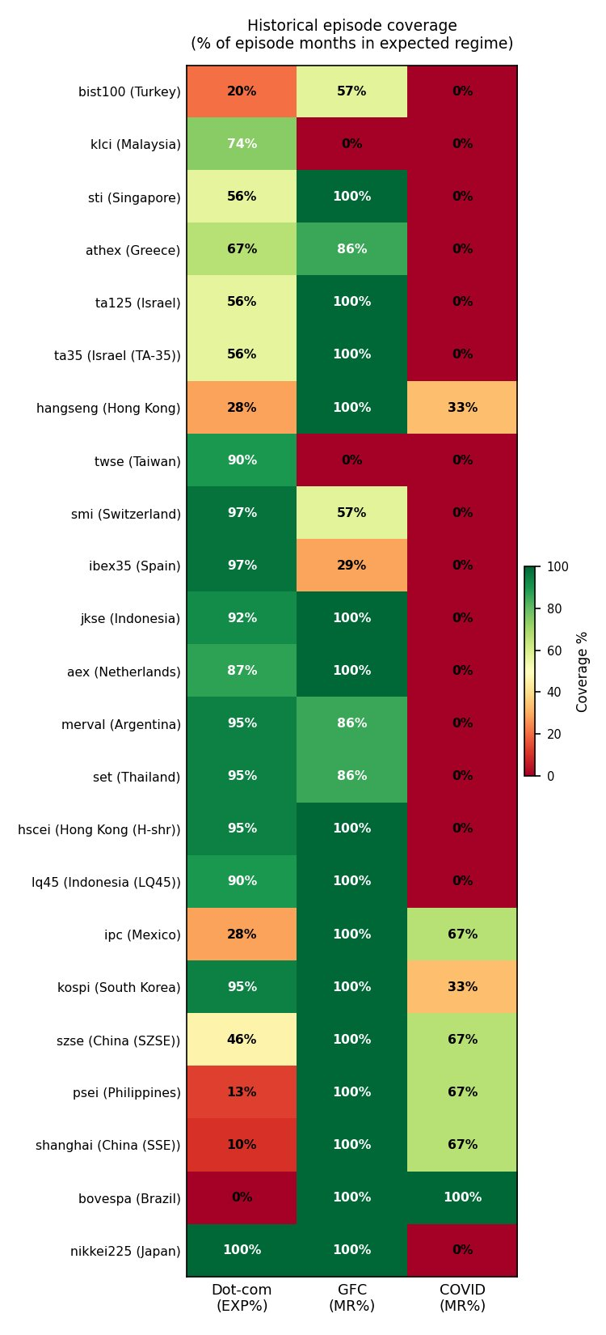

Appendix C. National-global sentiment correlations
First-difference correlations $ρ_{i}$ between each country’s CCI and the global aggregate, sorted from most idiosyncratic to most aligned.
Table C.1. National against global sentiment, first-difference correlations.
Country | n | Window | corr(dCCI country, dCCI global)
China (fetched FRED CSCICP03CNM665S) | 407 | 1990-01 to 2023-12 | 0.253
New Zealand | 423 | 1988-06 to 2023-09 | 0.286
Greece | 468 | 1985-01 to 2024-01 | 0.368
Turkey | 240 | 2004-01 to 2024-01 | 0.376
Czechia (PX) | 348 | 1995-01 to 2024-01 | 0.415
Australia | 528 | 1980-01 to 2024-01 | 0.435
Finland | 434 | 1987-11 to 2024-01 | 0.482
Ireland | 516 | 1980-01 to 2023-01 | 0.485
France | 528 | 1980-01 to 2024-01 | 0.485
Italy | 528 | 1980-01 to 2024-01 | 0.494
Austria | 528 | 1980-01 to 2024-01 | 0.501
Mexico | 272 | 2001-04 to 2023-12 | 0.507
Germany | 528 | 1980-01 to 2024-01 | 0.523
Denmark | 528 | 1980-01 to 2024-01 | 0.524
Belgium | 528 | 1980-01 to 2024-01 | 0.534
Poland (WIG20) | 272 | 2001-05 to 2024-01 | 0.551
Netherlands | 528 | 1980-01 to 2024-01 | 0.563
Portugal | 451 | 1986-06 to 2024-01 | 0.570
Switzerland | 526 | 1980-01 to 2023-11 | 0.577
Canada | 455 | 1980-01 to 2017-12 | 0.590
South Korea | 300 | 1998-12 to 2023-12 | 0.603
UK | 528 | 1980-01 to 2024-01 | 0.617
Sweden | 339 | 1995-10 to 2024-01 | 0.634
Japan | 501 | 1982-04 to 2024-01 | 0.666
Spain | 451 | 1986-06 to 2024-01 | 0.705
USA | 528 | 1980-01 to 2024-01 | 0.808
Note to Table C.1: national confidence series are drawn from the OECD amplitude-adjusted panel. China’s series was retrieved separately from FRED (CSCICP03CNM665S), which accounts for its differing sample window relative to the other 25 countries.

Appendix D. Robustness

D.1 Frozen-threshold stability
Option A (full-sample estimation) and Option B (thresholds estimated through mid-2015 and frozen thereafter) agree for 88.2 percent of index-months over the full sample and 84.6 percent after 2015. Panel-wide chance-corrected agreement is kappa = 0.74. The S&P 500/MCSI self-agreement exercise gives kappa = 0.94, but it covers one index and is not an equal-coverage panel comparison. Agreement exceeds 94 percent in every threshold-cluster index and is much lower in the fitted outliers (Shanghai 22 percent, Shenzhen 37 percent, the Philippines 52 percent and Mexico 76 percent). The same fitted outliers also show lower label stability across estimation windows; this co-occurrence does not by itself establish trigger-domain mismatch. Of the disagreeing months, 38.8 percent have the trigger within 0.25 units of a threshold, so most disagreements reflect different threshold estimates rather than boundary noise.

D.2 Generated-classification uncertainty
The full grid search is re-estimated in every bootstrap draw (B = 1,000). Under the wild bootstrap, which conditions on the observed CCI path, the median 95 percent interval widths across indices are 2.14 for the lower threshold, 1.00 for the upper threshold, 37 percentage points for the random-walk share and 13 for the high-sentiment share. Under a 24-month moving-block bootstrap of the dependent variable and trigger, the corresponding widths are 2.93, 2.68, 67 and 62. High-band slope intervals exclude zero in six indices under the wild scheme and five under the 24-month block. A separate calendar-month cross-section resample with full re-estimation gives pooled twelve-month gaps of +8.18 points for low sentiment minus random walk (MR-RW; 95 percent interval +2.52 to +15.41) and -10.88 for high sentiment minus random walk (EXP-RW; -18.23 to -4.32). The calendar-month resample preserves contemporaneous cross-index dependence and threshold re-estimation but not overlapping-return serial dependence, so it complements rather than replaces the moving-block and Driscoll-Kraay inference.

D.3 Regime restrictions and minimum sizes
In unrestricted middle-band regressions, 16 slopes are negative and seven positive. Six reject zero at the raw 5 percent level, but none survives Benjamini-Hochberg correction at q = 0.05; the median slope is -0.0063. Minimum-band rules of 5, 10 and 15 percent and 20, 30 and 40 observations leave every index feasible. The high-sentiment-minus-random-walk gap remains negative under all six rules (-5.12 to -13.21 points), while Spearman correlations between the resulting random-walk-share rankings and the baseline range from 0.247 to 0.836. These checks do not contradict the panel restriction and preserve the return-gap sign more clearly than they preserve the exact ranking.

D.4 Fixed-tail, recursive and publication-lag benchmarks
The direct test of equality between the TAR high-band coefficient (-11.28) and the fixed above-90th coefficient (-4.36) does not reject under Driscoll-Kraay errors (p = 0.516) or a 24-month calendar-block bootstrap (p = 0.618). In the expanding-window final-vintage exercise, twelve-month means are -16.93 percent after TAR high-band labels and -21.92 after fixed high-tail labels; both indicators remain significant in the encompassing regression, while predictive R-squared values are 0.013 and 0.008 and forecast errors are nearly identical. Publication-lag re-estimation preserves the EXP-RW gap at one month (-15.90; Driscoll-Kraay p = 0.025), but the two-month gap (-12.26) does not reject under 12-, 24- or 36-month block bootstraps.

D.5 Scale and placebo diagnostics
Across the eight national CCI distributions, a level of 100 lies between the 38th and 51st percentiles, while 97.7 lies between the 4th and 28th and 101.4 between the 63rd and 87th. For Greece, replacing the raw national CCI with its percentile rank leaves the fitted shares almost unchanged (43.8 / 31.5 / 24.6 percent against 43.5 / 31.2 / 25.2), whereas Turkey is much more sensitive. The Greek near-invariance is expected under a monotonic rank re-expression and is reported as a numerical-scale sensitivity check, not as independent validation of the trigger. In 1,000 placebo simulations per index, the real RSS improvement exceeds an i.i.d. null at the 5 percent level in 9 of 23 indices but a 12-month block-resampled null in only 3. Under the common trigger the common scale and fitted thresholds are therefore useful modelling devices, not evidence of distributional equivalence or structural threshold identification. The identical placebo clears the block-resampled null for both original Ahmed and Satchell pairings (C54) and fails for the S&P 500 under the global CCI (C55).

D.6 Reproduction status of the Section 6.3 robustness checks
Each row is taken from the verification pipeline output rather than transcribed from the text, so the reproduced column records what the committed code returns. Where a reproduced value differs from the figure quoted in Section 6.3, the reproduced value is the one to cite.
Table D.1. Reproduction status of the robustness checks reported in Section 6.3.
ID | Check | Verdict | Reproduced value
A12 | Fixed-tail percentile cuts against the TAR spread | MATCH ‡ | cuts 98.33 / 101.39; below +17.84, above −4.57; fixed-tail spread 22.40pp; TAR spread 22.09pp
A14 | Five calendar-year clusters, year-collapsed test | MATCH | t = −3.155, p = 0.0343, clusters = 5
C37 | Episode spells excluding Japan | MATCH | 30 episodes, mean length 20.5 months, mean excess −15.04, 26 negative
C39 | Circular-shift permutation, 5,000 draws | MATCH | p (≤ observed) = 0.0, B = 5,000
C40 | Trailing-return control | MATCH | −14.0682 → −14.0647; trailing p = 0.5052; Driscoll-Kraay p = 0.057
C41 | Asian-crisis exclusion | MATCH | −11.45, p = 0.017; excluded spells mean −26.843 (n = 7)
C42 | One index per country | MATCH | −14.93, p = 0.0062
C43 | Japan reinstated in the pooled twelve-month mean | MATCH | −7.49 (n = 615) → −6.08 (n = 879)
C45 | Frozen-threshold post-2015 out-of-sample test | NEAR † | n_EXP = 76, years = 4, indices = 4, gap = −9.839, Driscoll-Kraay p = 0.1876, block p = 0.2176
† NEAR: the check reproduces the qualitative claim but not to the precision quoted in Section 6.3. ‡ The fixed-tail spread and the lower percentile cut reproduce at 22.40pp and 98.33 against manifest targets of 22.14pp and 98.39. The verification check was corrected to report NEAR rather than MATCH, and Section 6.3 now cites the reproduced values. All other rows reproduce to the precision shown.

References
- Ahmed, M.F. and Satchell, S. (2018). What proportion of time is a particular market inefficient? A method for analysing the frequency of market efficiency when equity prices follow threshold autoregressions. Journal of Time Series Econometrics, 10(2), 20160021. DOI: 10.1515/jtse-2016-0021.
- Baker, M. and Wurgler, J. (2006). Investor sentiment and the cross-section of stock returns. Journal of Finance, 61(4), 1645-1680.
- Baker, S.R., Bloom, N. and Davis, S.J. (2016). Measuring economic policy uncertainty. Quarterly Journal of Economics, 131(4), 1593-1636.
- De Bondt, W.F.M. and Thaler, R. (1985). Does the stock market overreact? Journal of Finance, 40(3), 793-805.
- dos Santos, M.A., Fávero, L.P.L., Brugni, T.V. and Serra, R.G. (2024). Adaptive markets hypothesis and economic-institutional environment: a cross-country analysis. Revista de Gestão (REGE), 31(2), 215-236. DOI: 10.1108/REGE-06-2022-0095.
- Driscoll, J.C. and Kraay, A.C. (1998). Consistent covariance matrix estimation with spatially dependent panel data. Review of Economics and Statistics, 80(4), 549-560.
- Evans, G.W. (1991). Pitfalls in testing for explosive bubbles in asset prices. American Economic Review, 81(4), 922-930.
- Fama, E.F. (1965). The behavior of stock-market prices. Journal of Business, 38(1), 34-105.
- Fama, E.F. (1970). Efficient capital markets: A review of theory and empirical work. Journal of Finance, 25(2), 383-417.
- Granger, C.W.J. (1969). Investigating causal relations by econometric models and cross-spectral methods. Econometrica, 37(3), 424-438.
- Hansen, L.P. and Hodrick, R.J. (1980). Forward exchange rates as optimal predictors of future spot rates: An econometric analysis. Journal of Political Economy, 88(5), 829-853.
- Harvey, D.I., Leybourne, S.J. and Whitehouse, E.J. (2020). Date-stamping multiple bubble regimes. Journal of Empirical Finance, 58, 226-246.
- Knight, J. and Satchell, S.E. (2011). Some new results for threshold AR(1) models. Journal of Time Series Econometrics, 3(2), Article 1, 1-42.
- Knight, J., Satchell, S.E. and Srivastava, N. (2014). Steady state distributions for models of locally explosive regimes: Existence and econometric implications. Economic Modelling, 41, 281-288.
- Künsch, H.R. (1989). The jackknife and the bootstrap for general stationary observations. Annals of Statistics, 17(3), 1217-1241.
- Li, Y., Wang, Z., Wang, H., Wu, M. and Xie, L. (2021). Identifying price bubble periods in the Bitcoin market-based on GSADF model [sic]. Quality & Quantity, 55(5), 1829-1844. DOI: 10.1007/s11135-020-01077-4.
- Lo, A.W. (2004). The adaptive markets hypothesis: Market efficiency from an evolutionary perspective. Journal of Portfolio Management, 30(5), 15-29.
- Monschang, V. and Wilfling, B. (2021). Sup-ADF-style bubble-detection methods under test. Empirical Economics, 61(1), 145-172.
- Munir, A.F., Abd. Sukor, M.E. and Shaharuddin, S.S. (2022). Adaptive market hypothesis and time-varying contrarian effect: Evidence from emerging stock markets of South Asia. SAGE Open, 12(1), 21582440211068490.
- Noda, A. (2016). A test of the adaptive market hypothesis using a time-varying AR model in Japan. Finance Research Letters, 17, 66-71.
- Noda, A. (2021). On the evolution of cryptocurrency market efficiency. Applied Economics Letters, 28(6), 433-439.
- Okorie, D.I. and Lin, B. (2021). Adaptive market hypothesis: The story of the stock markets and COVID-19 pandemic. North American Journal of Economics and Finance, 57, 101397.
- Petersen, M.A. (2009). Estimating standard errors in finance panel data sets: Comparing approaches. Review of Financial Studies, 22(1), 435-480.
- Phillips, P.C.B., Shi, S. and Yu, J. (2014). Specification sensitivity in right-tailed unit root testing for explosive behaviour. Oxford Bulletin of Economics and Statistics, 76(3), 315-333.
- Phillips, P.C.B., Shi, S. and Yu, J. (2015). Testing for multiple bubbles: Historical episodes of exuberance and collapse in the S&P 500. International Economic Review, 56(4), 1043-1078. (Companion paper: Testing for multiple bubbles: Limit theory of real-time detectors, same issue, 1079-1134.)
- Phillips, P.C.B., Wu, Y. and Yu, J. (2011). Explosive behavior in the 1990s Nasdaq: When did exuberance escalate asset values? International Economic Review, 52(1), 201-226.
- Samuelson, P.A. (1965). Proof that properly anticipated prices fluctuate randomly. Industrial Management Review, 6(2), 41-49.
- Schmeling, M. (2009). Investor sentiment and stock returns: Some international evidence. Journal of Empirical Finance, 16(3), 394-408.
- Shternshis, A., Mazzarisi, P. and Marmi, S. (2022). Measuring market efficiency: The Shannon entropy of high-frequency financial time series. Chaos, Solitons & Fractals, 162, 112403.
- Skrobotov, A. (2023). Testing for explosive bubbles: a review. Dependence Modeling, 11(1), 20220152.
- Urquhart, A. and McGroarty, F. (2016). Are stock markets really efficient? Evidence of the adaptive market hypothesis. International Review of Financial Analysis, 47, 39-49.
- Vuong, N.B. and Suzuki, Y. (2022). The moderating effect of market-specific factors on the return predictability of investor sentiment. SAGE Open, 12(3), 21582440221114322.
- Welch, B.L. (1947). The generalization of “Student’s” problem when several different population variances are involved. Biometrika, 34(1-2), 28-35.
- Whitehouse, E.J., Harvey, D.I. and Leybourne, S.J. (2023). Real-time monitoring of bubbles and crashes. Oxford Bulletin of Economics and Statistics, 85(3), 482-513.
Data source. OECD, composite consumer confidence indicator, amplitude-adjusted, monthly (SDMX dataflow DSD_STES@DF_CLI, REF_AREA OECD, subject CCICP); country indicators via FRED, series CSCICP03M665S.

